# CHAPTER-1

# INTRODUCTION

* 1. **Introduction to Big Data Hadoop**

The term Big Data refers to all the data that is being generated across the globe at an unprecedented rate. This data could be either structured or unstructured. Today’s business enterprises owe a huge part of their success to an economy that is firmly knowledge-oriented. Data drives the modern organizations of the world and hence [making sense of this data](https://intellipaat.com/hadoop-developer-training/) and unravelling the various patterns and revealing unseen connections within the vast sea of data becomes critical and a hugely rewarding endeavor indeed. There is a need to convert Big Data into [Business Intelligence](https://intellipaat.com/all-courses/business-intelligence/) that enterprises can readily deploy. Better data leads to better decision making and an improved way to strategize for organizations regardless of their size, geography, market share, customer segmentation and such other categorizations. [Hadoop is the platform of choice](https://intellipaat.com/big-data-hadoop-training/#curriculum) for working with extremely large volumes of data. The most successful enterprises of tomorrow will be the ones that can make sense of all that [data at extremely high volumes and speeds](https://intellipaat.com/tutorial/big-data-and-hadoop-tutorial/introduction-to-big-data-2/) in order to capture newer markets and customer base apache Hadoop is an open source software framework for storage and large scale processing of data-sets on clusters of commodity hardware. Hadoop is an apache top- level project being built and used by a global community of contributors and users.



Fig -1.1.Big Data Hadoop [1]

# Necessity

The necessity of Big Data Hadoop in real world is very crucial. As it is a necessity for us to process data faster, handling the growing data rates otherwise it will be very tough for us to get output through traditional database systems as they can process and analyze only limited amount of data. Hence Big Data Hadoop not only processes data but also helps in storing data through its various frameworks. Thus because of growing data rates and for processing data faster Big Data Hadoop has become a necessity for the MNC’s.

# Objectives

The objective of the training is to learn about Big Data Hadoop as with growing amount of data it has become a necessity in the real world. With the help of Big Data Hadoop following problems can be solved easily:

* + - Processing exponentially growing datasheets.
    - Processing data faster.
    - Processing complex data.

# Organization

In this report I have mentioned about the basic introduction of Big Data Hadoop in chapter 1 and then I have discussed how Big Data Hadoop was successful in overcoming the problems related to data and which works were used for storage and processing purpose and then finally concluded it by telling the major use of this Big Data Hadoop and its use in real world.

# Theme

The main theme of Big Data Hadoop training is to get an idea about the analysis, processing of data. Big data Hadoop includes various framework: hive, pig, zookeeper, scala, oozie, flume, map reduce which are used for analyzing data processing the data and for downloading real time data. Spark is also part of part of Big data and is a very vast framework and is used in downloading the real time data which is the future of hadoop. The future of hadoop includes machine learning and artificial intelligence. The theme of this training program is to produce Enterprise Networking professionals capable of implementing, administering, maintaining Computer Networks and overall Security Systems. It is an advanced level program that measures the ability to administer any networking problems , This program has been designed to keep in mind that in now day’s scenario for engineering graduate students from any stream. Industrial training is must for every student pursuing professional degree because the ultimate goal of every student is to get the information the industrial training helps us to get an idea of things. Spark is also part of part of big data and is a very vast framework and is used in downloading the real time data which is the future of hadoop. Big data Hadoop includes various framework: hive, pig, zookeeper, scala, oozie, flume, and map reduce are used for analyzing data processing the data and for downloading real time data.

# CHAPTER 2

**Big Data Hadoop**

* 1. **Evolution of Data**

We have to evolution of data in different teams like:

* + - Evolution of technology
    - IOT(Internet of think)
    - Social Media and some other factors.

# Evolution of technology

1990 year. We use some devices like phone, cameras, telephone etc. this devices are generate data but less amount. Now day by day we use a new technology like smart phone, digital cameras, internet, tablets etc. are generate huge amount of data.



Fig - 2.1 Evolution of Technology [2]

# Internet of thing (IOT)

IOT is the stand for INTERNET OF THING

The network of physical devices, vehicles, home appliances and other .these objects to connect and exchange data .according to IOT 2020 yr. we use a 50 billion devices.

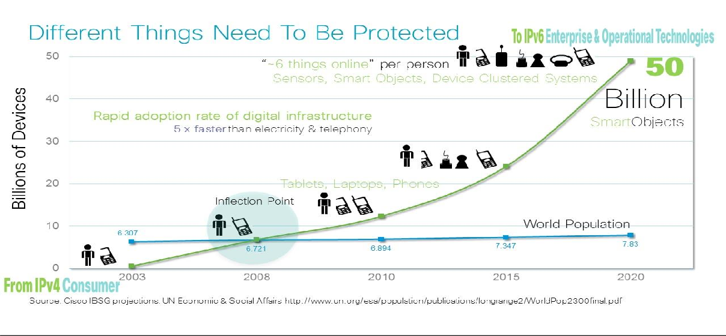

Fig -2.2 Graph of Internet of Think [3]

* + 1. **Social media**

Social media is one of big data most significant sources for lead generation. 90% of the available data in the word was collected over just the last two years. And 80% of that data comes from unstructured sources. The data generated by face book and other social channels on a daily basis is huge.

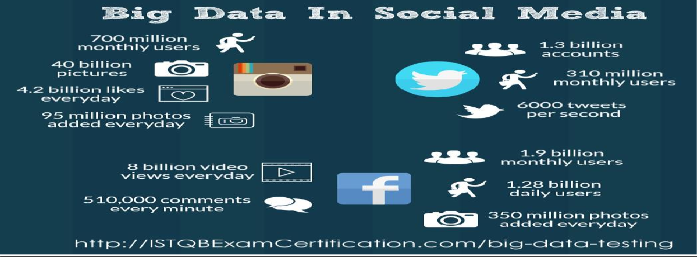

Fig-2.3 Social Media [4]

# Different kind of Factors

Now other some factors are generate a big amount of data like Banking and Securities, Transportation, Education, Media and Entertainment, and Health Care.

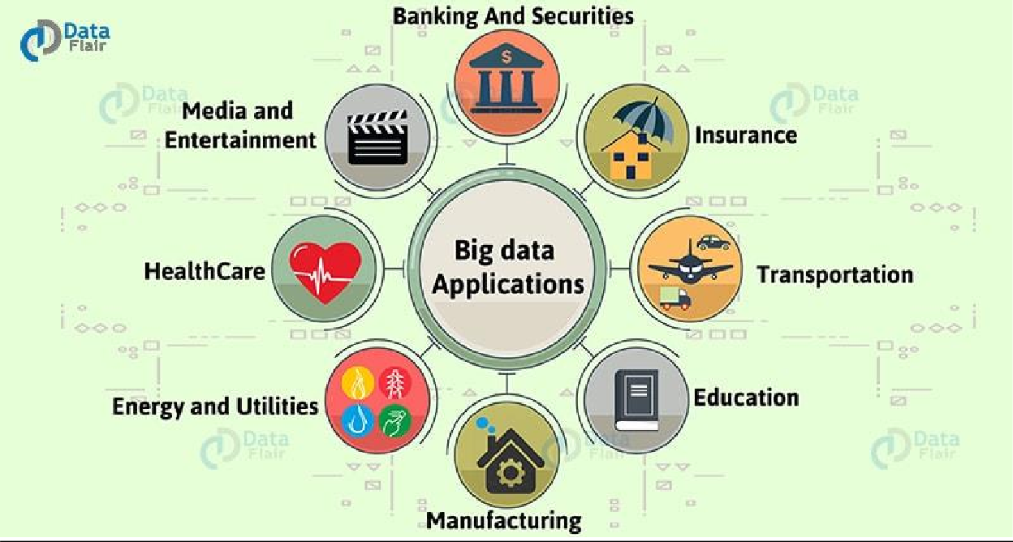

Fig -2.4 Different Kind of factors [5]

* 1. **What is big data**

Big data is the terms for collection of data sets so large and complex that it becomes difficult to process using on –hand database systems tool or traditional data processing application. And it’s also a data but with a huge size.



Fig – 2.5. Big Data [6]

* 1. **5V’S OF BIG DATA** 
     + VOLUME
     + VELOCITY
     + VALUE
     + VARIETY
     + VERACITY

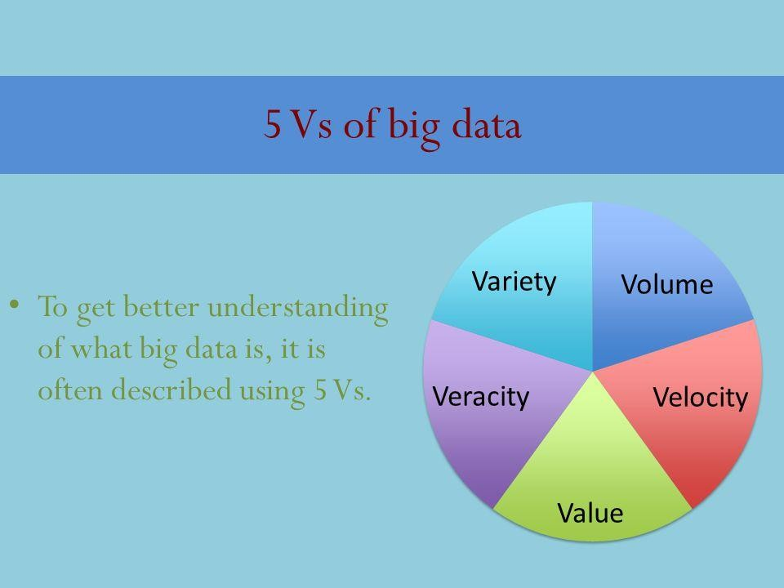

Fig -2.6 5v’s Big Data [7]

Big data is the terms for collection of data sets so large and complex that it becomes difficult to process using on –hand database systems tool or traditional data processing application and it’s also a data but with a huge size.

* + 1. **Volume: -** The large amount of data is generated in the form of terabytes as well as zeta-bytes. In 2020 year accumulated digital universe of data will grow from 4.4 zeta-bytes today to around 44 zeta-bytes or 44 trillion gigabytes. Volume refers to the vast amounts of data generated every second. Just think of all the emails, twitter messages, photos, video clips, sensor data etc. we produce and share every second. We are not talking Terabytes but Zeta-bytes and Petabytes.

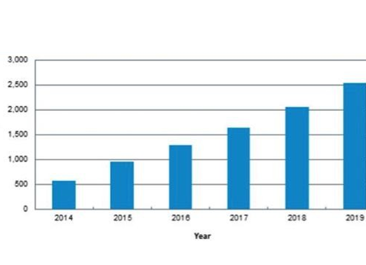

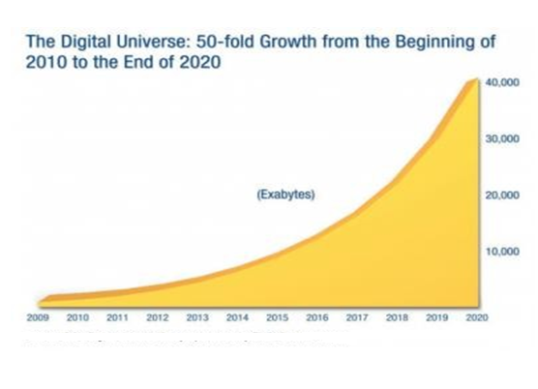

Fig - 2.7 Increasing Growth of Data [8]

* + 1. **Velocity**

It is refers to the speed at which new data is generate and the speed at which data moves around. For e.g. Social media messages going viral in seconds.

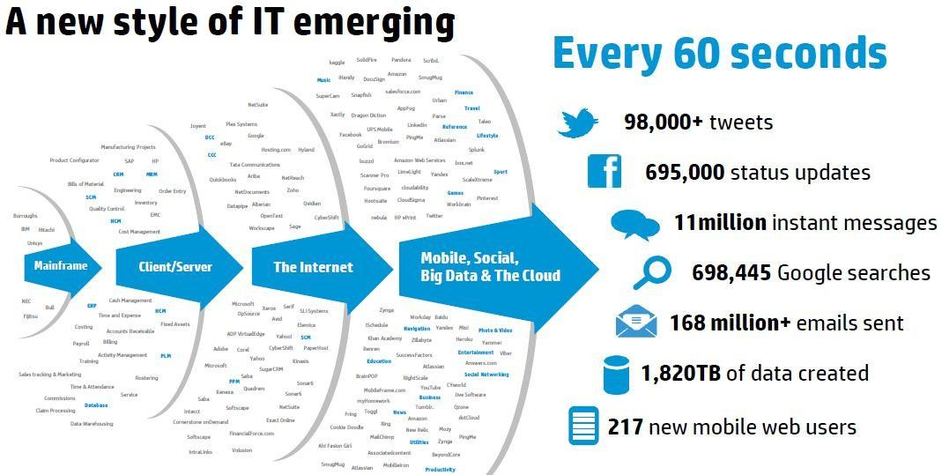

Fig -2.8 Rate of Data [9]

* + 1. **Values**

Having access to big data is no good unless we can turn it into value.

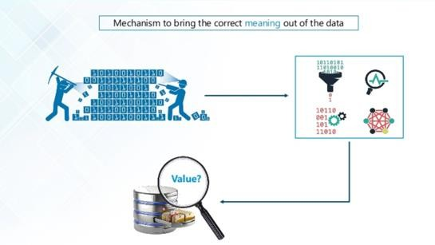

Fig -2.9 Mechanism of Data [10]

* + 1. **Variety**

Data is not just numbers, date, and string. Big data is also 3D data, audio and videos, unstructured and structured, semi structured and including log file, social media.

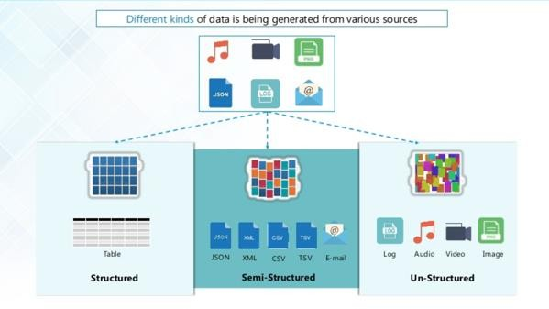

Fig -2.10 Different Kind of Data [11]

* + 1. **Veracity**

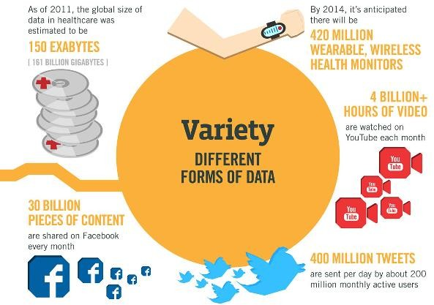Trustworthiness of the data. , data quality is unreliable, data coming from uncontrolled environment.

Fig-2.11 Uncerenity of Data [12]

# Big Data as an Opportunity

According to analysis made by IBM, managing huge amount of data and the velocity at which information is generated by short intervals reads of smart meter data can overwhelm existing IT resources.

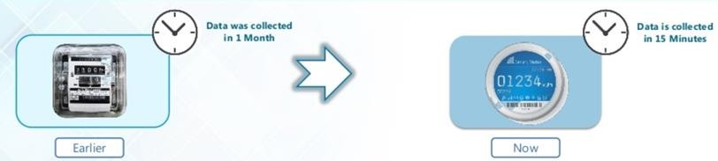

Fig 2.12 Big Data as an Opportunity [13]

The above fig shows that earlier data was being collected in one month now with the help of smart meters we can do this in just 15 minutes. Now managing and using the collected information in such a way so that we can gain something out of it is a thing to do, hence we store it and then we analyze it so that we can get valuable information.

# PROBLEMS WITH ENCASTING OPPORTUNITY

* + - Storing exponentially growing huge data sets
    - Processing data having complex structure.
    - Processing data faster
    1. **Problem 1.** – Storing exponentially growing huge data sets.

There are many sources that predict exponential data growth toward 2020 and beyond. Yet they are all in broad agreement that the size if the digital universe will double every two year at least, a 50-flod growth from 2010 to 2020 .human and machine generated data is experiencing an overall 10x faster growth rate than traditional business data, and machine data is increasing even more rapidly at 50x the growth rate.

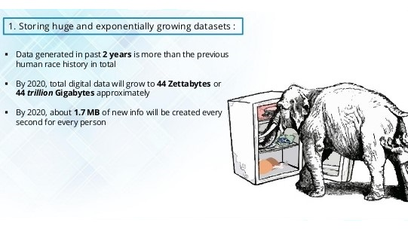

Fig -2.13 Storing Exponentially Growing Huge Data Sets. [14]

* + 1. **Problem 2**

Processing data having complex structure.

We will find a data / generate in different from like structure data, un-structure data and semi –structure data.

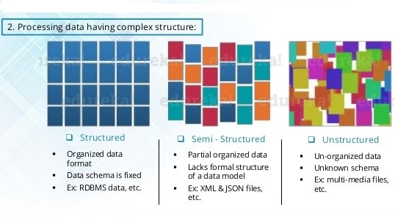

Fig -2.14 Processing Data Having Complex Structure. [15]

* + 1. **Problem 3**

Processing data faster.

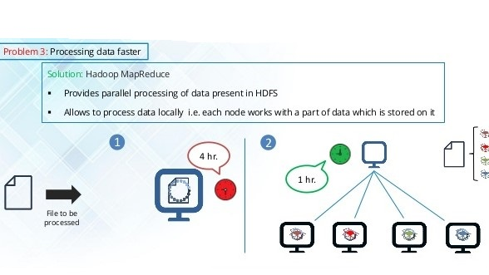

Fig -2.15 Processing Data Faster. [16]

# Hadoop as a Solution

HADOOP – Hadoop is an open source framework from Apache and is used to store process and analyze data which are very huge in volume. Hadoop is written in Java and is not OLAP (online analytical processing). It is used for batch/offline processing. It is being used by Facebook, Yahoo, Google, Twitter, LinkedIn and many more.

Hadoop is distributed two parts HDFS and MAP REDUCE.

* + 1. **HDFS** is stand for Hadoop distributed file system .it is allows to dump any kind of data across the cluster. It creates a level of abstraction over the resource, from where we can see the whole HDFS as a single unit. HDFS is use to very large file, streaming data access, and commodity hardware.

HDFS has two core components

* + - * NAME NODE (MASTER)
      * DATA NODE (SLAVE)

# Name Node

Name node is the main node that contain metadata about the data stored .Name node is also known as a JOB TRACKER .

# Data Node

Data is the stored on the data nodes which are commodity hardware in the distributed system. Data node is also known as a Task Tracker.

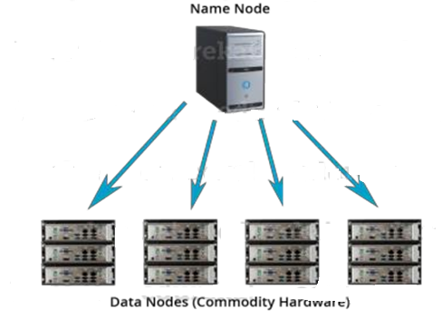

Fig -2.16 (Name Node) (Data Node) [17]

Hadoop Distributed File System is a block-structured file system where each file is divided into blocks of a pre-determined size. These blocks are stored across a cluster of one or several machines. Apache Hadoop HDFS Architecture follows a *Master/Slave Architecture*, where a cluster comprises of a single Name Node (Master node) and all the other nodes are Data Nodes (Slave nodes). HDFS can be deployed on a broad spectrum of machines that support Java. Though one can run several Data Nodes on a single machine, but in the practical world, these Data Nodes are spread across various machines. These blocks are stored across a cluster of one or several machines. Apache Hadoop HDFS Architecture follows a Master/Slave Architecture,

# ARCHITECTURE OF HDFS

Name Node is the master node in the Hadoop HDFS Architecture that maintains and manages the blocks present on the Data Nodes (slave nodes). Name Node is a very highly available server that manages the File System Namespace and controls access to files by clients. I will be discussing this High Availability feature of Hadoop HDFS in my next blog. The HDFS architecture is built in such a way that the user data never resides on the Name Node. The data resides on Data Nodes only.

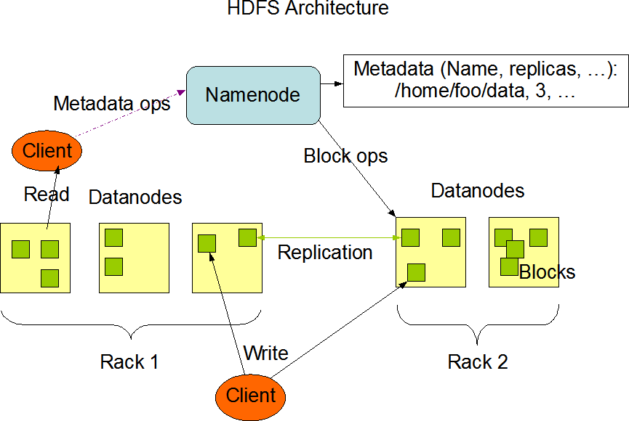

Fig-2.17 Architecture of HDFS [18]

# Function of Name Node

* + - * + It is master daemon that maintains and manages the data nodes (slave nodes)
        + It records the metadata of all the files stored in cluster for e.g. Location of blocks stored, the size of the files, etc.
        + It records each change that takes place to the file system metadata. For e.g. If a file is deleted in HDFS, the name node will immediately record this in the edit log.
        + The Name Node is also responsible to take care of the replication factor of all the blocks.
        + In case of the Data Node failure, the Name Node chooses new Data Nodes for new replicas, balance disk usage and manages the communication traffic to the Data Nodes.

# Function of Data Node

* + - * + These are slave daemons or process which runs on each slave machine.
        + The actual data is stored on Data Nodes.
        + The Data Nodes perform the low-level read and write requests from the file systems clients.
        + They send heartbeats to the Name Node periodically to report the overall health of HDFS, by default, this frequency is set to 3 seconds.
      1. **Secondary name node**

These two daemons, there is a third daemon or a process called Secondary Name Node. The Secondary Name Node works concurrently with the primary Name Node as a helper daemon. And don’t be confused about the Secondary Name Node being a backup Name Node**.**

* + - 1. **Blocks**

A blocks is minimum amount of data that it can read or write. HDFS blocks are 128 MB by default and this configurable files and HDFS are broken into block-sized chunks, which are stored as independent units. If file in HDFS is smaller than blocks size, then it doesn’t occupy full blocks sizes, i.e. the 5 MB file of stored in HDFS of blocks size 128MB takes 5MB spaces only.

Let show example, we have a file (“example.txt”) of size is 514 MB .which is divided a blocks, the blocks are stored a file is 128MB and created a 5 blocks each size is 128 MB and last blocks will be of 1mb size only.

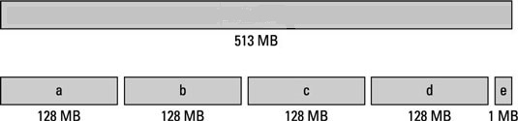

Fig-2.18 Blocks [19]

# Replication Management

HDFS provide a reliable way to store huge data in a distributed environment as data blocks. The blocks are also replicated to provide fault tolerance .the default replication factor is 3 which is again configurable. The replication or copy file is minimum time 3 sec. the time change according to user.

# Map Reduce

Map Reduce is a programming framework that allows us to perform distributed and parallel processing on large datasets. Map Reduce includes three classes namely:

* + - * Mapper class
      * Reducer class
      * Driver class

Mapper: - The Mapper input is in the form of key and value. Key is in the form of long writable and Value is in the form of Text.

Reducer: - The Reducer input is in the form of key and value. Key is in the form of Text and Value is in the form of int writable

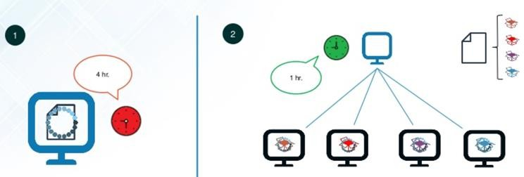

Fig 2.19 Map Reduce [20]

It is a method for distributing computation across multiple nodes. Each node processes the data which is again get stored in that node. Map Reduce consists of two main phases- Mapper phase, Shuffle and Sort phase, Reducer Phase.

**Mapper Phase-** It reads data as key/value pairs and outputs the data in the form of zero or more key/value pairs.

**Shuffle and Sort Phase-** Output from the mapper is sorted by key and all the values with the same key are guaranteed to go to the same machine.

**Reducer Phase-** It merges the output of previous phase by being called once for each unique key and thus outputs zero or more final key/value pairs (usually just one output per input key).

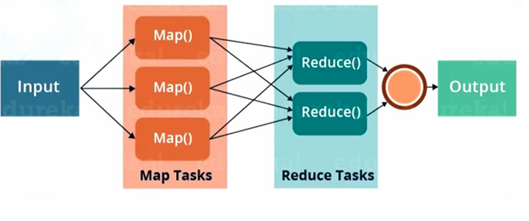

Fig 2.20 Map Reduce Architecture [21]

# Flume

Apache Flume is a tool/service/data ingestion mechanism for collecting aggregating and transporting large amounts of streaming data such as log files, events, etc., from various sources to a centralized data store. Flume is a highly reliable, distributed and configurable tool. It is principally designed to copy streaming data (log data) from various web servers to HDFS.

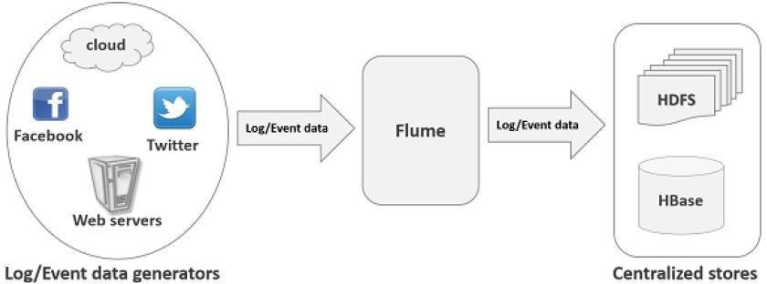

Fig 2.21 Flume [22]

The following illustration depicts the basic architecture of Flume. As shown in the illustration, **data generators** (such as, Facebook, Twitter) generate data which gets collected by individual Flume **agents** running on them. Thereafter, a **data collector** (which is also an agent) collects the data from the agents which is aggregated and pushed into a centralized store such as HDFS or Hbase.

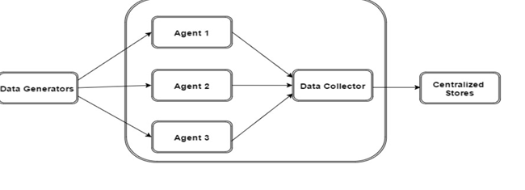

Fig.2.22 Flume Architecture [23]

**Flume Installation**

**Step 1:** Download latest Flume release from Apache [Website.](http://archive.apache.org/dist/flume/)

**Step 2**: Move/Copy it to the location you want to install, in my case it is “/opt”.

**$cd Downloads/**

**$sudo cp apache-flume-1.6.0-bin.tar.gz /opt/**

Or

Copy by WinSCP into “/opt/”

**Step 3:** Extract the tar file. Go to the copied folder, in my case it is “/opt/”, run the below commands

**$ cd /opt**

**$ sudo tar–xzvf /opt/apache-flume-1.6.0-bin.tar.gz**

**Step 4:** Move the “flume-sources-1.0-SNAPSHOT” file into /opt/apache-flume-1.8.0-bin/lib

**By WinSCP**

**Step 5:** Update environments

**$ sudo nano ~/.bashrc**

Add Below Lines:

**exportFLUME_HOME=“/opt/apache-flume-1.8.0-bin” exportFLUME_CONF_DIR=$FLUME_HOME/conf exportFLUME_CLASSPATH=$FLUME_CONF_DIR**

**exportPATH=$PATH:$FLUME_HOME/bin**

**Step 6:** Reload ***.bashrc***

**$ source ~/.bashrc**

**Step 7:** Rename “**flume-env.sh.template**” to “**flume-env.sh**” and write the below values.

**$ sudo mv/opt/apache-flume-1.8.0-bin/conf/ flume-env.sh.template flume-env.sh**

**$ nano /opt/apache-flume-1.8.0-bin/conf/flume-env.sh**

Add below line (please use your installed java version)

**$JAVA_OPTS="-Xms500m -Xmx1000m -Dcom.sun.management.jmxremote"**

**Export JAVA_HOME=/usr/lib/jvm/java-8-oracle**

**FLUME_CLASSPATH="/opt/apache-flume-1.8.0-bin/lib/flume-sources-1.0- SNAPSHOT.jar"**

**Step 8:** Enter as hadoop and run flume CLI:

**$ flume-ng –help**

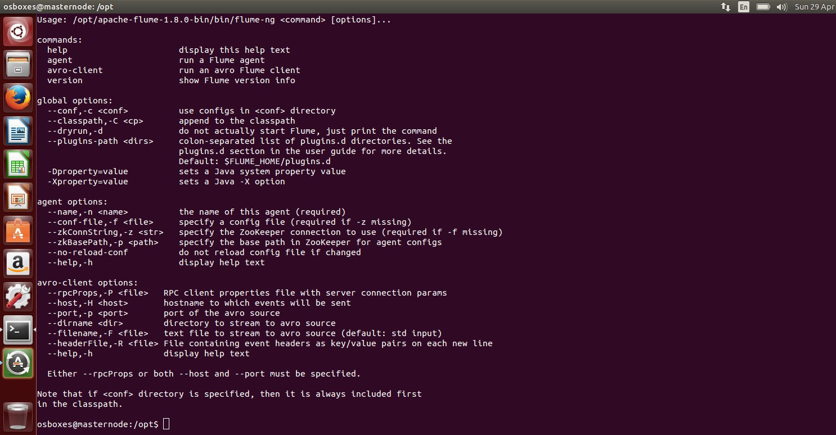

Fig 2.23 Flume installed

# Hive

**Apache Hive** is a data warehousing package built on the top of Hadoop that is used for data analysis. It was developed by Facebook to target towards users comfortable with SQL. Thus it is quite similar to SQL, it is also called Hive QL. It abstracts complexity of Hadoop as there is no need to learn Java and Hadoop APIs and therefore, used for managing and querying structured data. Facebook analyzes several Terabytes of data everyday using Hive.

Fig 2.24 Hive [24]

# Hive Installation

1. Download Hive latest version (During this tutorial hive-2.1.1 is the latest) from this [link](http://apache.mesi.com.ar/hive/hive-2.1.1/apache-hive-2.1.1-bin.tar.gz) (Use this link through CD). You will get “***apache-hive-2.1.1-bin.tar.gz”***file. Extract it to the folder where you want to install Hive. For that you can use Archive Manager or by terminal using the command

# tar -xzf apache-hive-2.1.1-bin.tar.gz

1. Setting up environment for Hive
   1. Edit .bashrc

**Sudo nano ~/.bashrc**

* 1. Add **HIVE_HOME** path

# export HIVE_HOME="/usr/local/hive" export PATH=$PATH:$HIVE_HOME/bin

* 1. Reload .bashrc

# Source ~/.bashrc

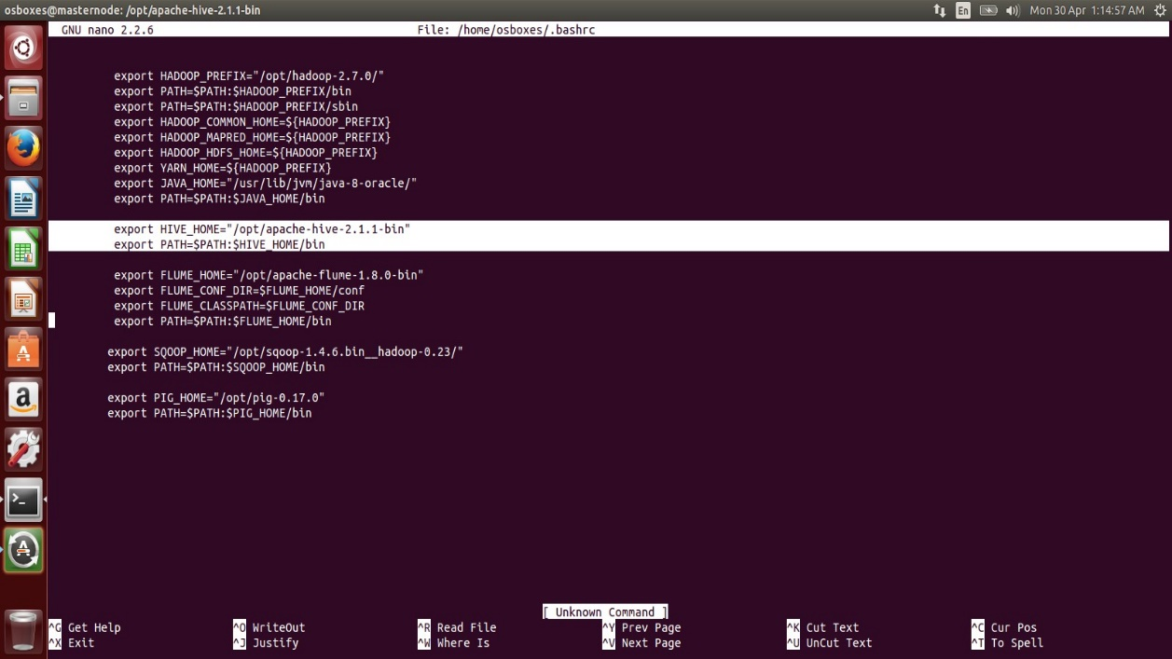

Fig. 2.25 Giving Path in Bashrc

Now, go to your hive directory and add HADOOP_HOME path. To do that follow below steps.

1. Open ***hive-config.sh*** file

# cd /usr/local/hive gedit bin/hive-config.sh

1. Add **HADOOP_HOME** path

# export HADOOP_HOME=/usr/local/Hadoop

We have to delete the jar file named “***log4j-slf4j-impl-2.4.1.jar*** “, which is located in “***lib***” folder of your hive directory. This is because hadoop has another log4j jar and when we run hive, there will be ambiguity to choose a log4j file and thus results in an error. So, we delete this log4j-slf4j- impl-2.4.1.jar file in “***apache-hive-2.1.1-bin/lib*”**folder.

# rm lib/log4j-slf4j-impl-2.4.1.j

Before running Hive, we have to create a ***warehouse*** folder for Hive in the HDFS file system. For that , start HDFS and yarn by running the following commands.

# sbin/start-dfs.sh sbin/start-yarn.sh

Check whether all the processes are running or not using **jps** command. If all the hadoop processes are running, then create a ware house folder in HDFS using the command-

# Hadoop fs -mkdir -p /usr/hive/warehouse

Now, provide read/write permissions to that folder using the command

# Hadoop fs -chmod 777 /usr/hive/warehoused

By default hive uses Derby, but still we have to specify it using ***“schematools”*** before running hive. To do that Open a terminal run the following commands.

# schematool -initSchema -dbType derby

Then, it will show a success message. If it doesn’t show a success message, then run the following

commands.**mv metastore_db metastore_db.tmschematool -initSchema -dbType derby**

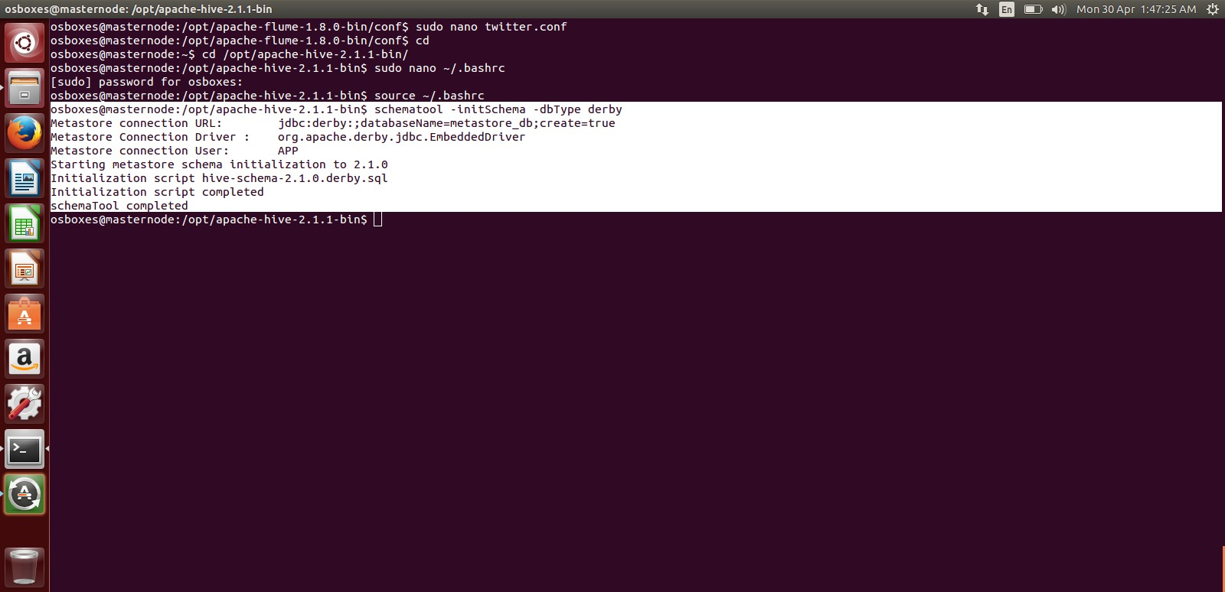

Fig. 2.26 Success Message

That’s it. Our hive installation is complete…!!

1. Run Hive

# hive

To run hive, just open a terminal and run hive. You will see a screen like below

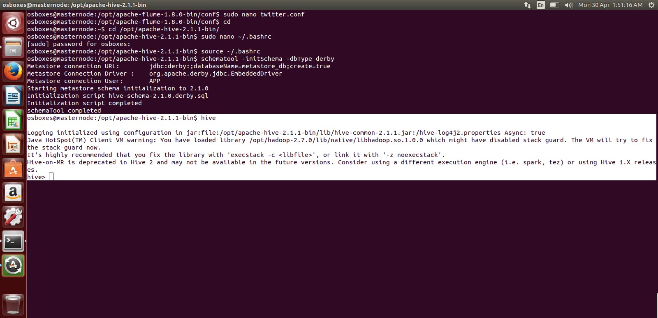

Fig. 2.27 Hive Started

# Hadoop Ecosystem

Hadoop Ecosystem includes various frameworks namely:

* 1. HDFS
  2. Map Reduce
  3. Hive
  4. Flume
  5. Pig
  6. Kafka
  7. H-base
  8. Zookeeper
  9. Oozie
  10. Scoop

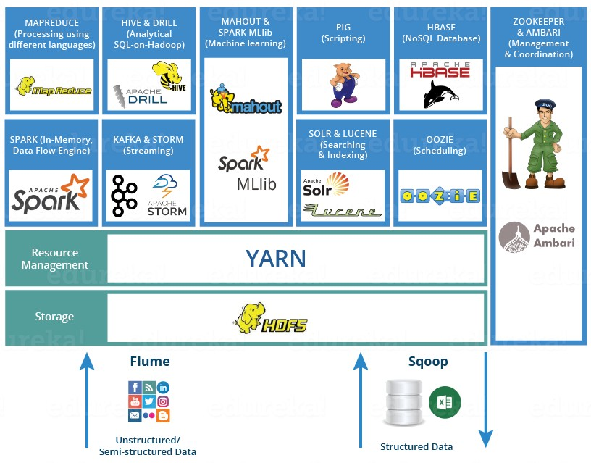

Fig-2.28 Hadoop Ecosystem [25]

* 1. **Sqoop**

It is a tool or a framework that is used for import the data from mysql to HDFS or vice versa.

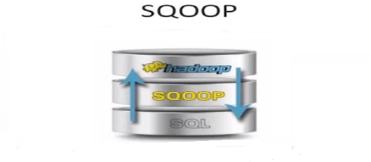

Fig-2.29 Sqoop [26]

# Sqoop Installation Steps:

Please follow the steps below to configure Sqoop on any of your VM:

1. Download the sqoop-1.4.5.tar release.
2. untar the release and copy it to /opt/sqoop-1.4.4
3. Open ~/.bash_profile
4. *export SQOOP_HOME=/opt/sqoop-1.4.5 export PATH=$PATH:$SQOOP_HOME/bin*
5. source ~/.bash_profile
6. To configure Sqoop with Hadoop, you need to edit the **sqoop-env.sh** file, which is placed in the **$SQOOP_HOME/conf** directory. First of all, Redirect to Sqoop config directory and copy the template file using the following command:

*export HADOOP_COMMON_HOME=/opt/hadoop-2.6.0 export HADOOP_MAPRED_HOME=/opt/hadoop-2.6.0*

1. Add the **attached** mysql connector jar to lib folder of sqoop.

We can download **mysql-connector-java-5.1.30.tar.gz** file from the following [link](http://ftp.ntu.edu.tw/MySQL/Downloads/Connector-J/).

The following commands are used to extract mysql-connector-java tar ball and move **mysql- connector-java-5.1.30-bin.jar** to /opt/sqoop/lib directory.

tar -zxf mysql-connector-java-5.1.30.tar.gz

cd mysql-connector-java-5.1.30

mv mysql-connector-java-5.1.30-bin.jar /opt/sqoop/lib

1. Verifying Sqoop

The following command is used to verify the Sqoop version.

*$ cd $SQOOP_HOME/bin*

*$ sqoop-version*

# 2.9.1 SOFTWARE INSTALLATION

PUTTY CONFIGURATION AND INSTALLATION

1. Steps for configuring Putty with Ubuntu by SSH

1. Go to network setting in virtiual box in network adapter select Nat on first and Host only on second adapter.
2. run sudo apt-get update
3. run ifconfig for checking current IP5
4. install ssh server by command sudo apt-get install openssh-server
5. run sudo nano /etc/network/interfaces and type this by erassing all

# interfaces(5) file used by ifup(8) and ifdown(8)

auto lo

iface lo inet loopback auto eth1

iface eth1 inet static address 192.168.56.101

netmask 255.255.255.0

1. change hostname by sudonano /etc/hostname

e.g hadoopnode1

1. run sudonano /etc/hosts and type this

127.0.0.1 localhost 192.168.56.101 hadoopnode1

# The following lines are desirable for IPv6 capable hosts

::1 ip6-localhost ip6-loopback fe00::0 ip6-localnet

ff00::0 ip6-mcastprefix ff02::1 ip6-allnodes ff02::2 ip6-allrouters

1. ssh-keygen 9.run ssh localhost
2. run ssh-copy-id -i localhost
3. check and run ssh localhost
4. ssh-copy-id -i hadoopnode1(name of host) 13.hostname

..............................

1. ssh-copy-id -i hadoopnode1
2. ssh hadoopnode1
3. sudonano /etc/hosts 17.sudo init 6

18. ~# ssh-copy-id -ilocalhostssh-copy-id -i localhost 19.check your IP address

20.restart and connect via Putty

# CHAPTER III

# TRAINING WORK

* 1. **Requirement specifications**

**Project Perspective**

The recent explosion in data pertaining to users on social media has created a great interest in performing sentiment analysis on this data using Big Data and Machine Learning principles to understand people's interests. This project intends to perform the same tasks. The difference between this project and other sentiment analysis tools is that, it will perform real time analysis of tweets.

# Operating Environment

This project needs to be operated in Linux operating system with the latest Java version installed. Since the project is based on Hadoop, so to run it we need to have this technology installed in the machine. For visualization process, Tableau software needed to be installed on the system. For the development purpose twitter provides streaming API which allows the developer an access to 1% of tweets tweeted at that time based on the particular keyword. The object about which we want to perform sentiment analysis is submitted to the twitter API’s which does further mining and provides the tweets related to only that object. For doing twitter data analysis first data is collected using FLUME in local HDFS. Tweets are preprocessed for removing noise and meaningless symbols. Feature vector is extracted. After that HIVE can be used for twitter posts analysis. Then we do visualization by making graphical representation and reports using data analysis.

**Functional Specification**

Collect tweets in a real time fashion i.e., from the twitter live stream based on specified keywords. Remove redundant information and noise from these collected tweets.

Store the formatted tweets in HDFS.

Perform Sentiment Analysis on the tweets stored in the HDFS to classify their nature viz. positive, negative and neutral.

Tweets are preprocessed for removing noise and meaningless symbols. Feature vector is extracted. After that HIVE can be used for twitter posts analysis. Then we do visualization by making graphical representation and reports using data analysis. Collect tweets in a real time fashion i.e., from the twitter live stream based on specified keywords. Remove redundant information and noise from these collected tweets. The object about which we want to perform sentiment analysis is submitted to the twitter API’s which does further mining and provides the tweets related to only that object. For doing twitter data analysis first data is collected using FLUME in local HDFS

# Project Overflow

**Twitter Streaming API**

**Extract Tweets using Flume**

**Load into HDFS**

**Data Processing and tweets**

**classification**

**Data Visualization**

Fig 3.1 Project Work Flow [27]

3**.3 ER Diagram**

**FRAMEWORK**

**HADOOP**

**FLUME**

**TWITTER API**

HIVE

PIG

FLUME

SQOOP

HIVE

HDFS

PIG

MAP

REDUCE

Fig 3.2 E-R Diagram

Twitter API is being accessed by Flume framework of Hadoop that fetches the data and load it into HDFS, from where further processing can be done using Hive, Pig or Map Reduce. The above diagram consists of Twitter API, Flume and Framework as entities which are in relationship with Hadoop. Flume, Hive, Sqoop, Pig are also as attributes of framework.

# Data Flow Diagram

**HADOOP**

**TWITTER APPS**

**DATA PROCESSING IN HIVE**

**TWITTER DATA**

Fig 3.3 Data Flow Diagram [28]

The above data flow diagram indicates the flow between each stage of the project, starting from Hadoop itself. Hadoop is the foundation for this project. Using Hadoop we access Twitter apps from where we fetch twitter data and collect it in Hadoop, then process it again using hive and store it in Hadoop. Twitter API is being accessed by Flume framework of Hadoop that fetches the data and load it into HDFS, from where further processing can be done using Hive, Pig or Map Reduce. The above diagram consists of Twitter API, Flume and Framework as entities which are in relationship with Hadoop. Flume, Hive, Sqoop, Pig are also as attributes of framework. This section consists of all the steps to be followed to achieve the objective of this project. Before starting the implementation, we must understand properly the entire cluster setup Hadoop is the foundation for this project. Using Hadoop we access Twitter apps from where we fetch twitter data and collect it in Hadoop, then process it again using hive and store it in Hadoop.

# Software Process model

Requirement

Analysis

Concept Specification

HDFS

Data Processing

Visualization

Handover

Streaming Twitter

API

Fig 3.4 Software Process model diagram

# Use Case Diagram

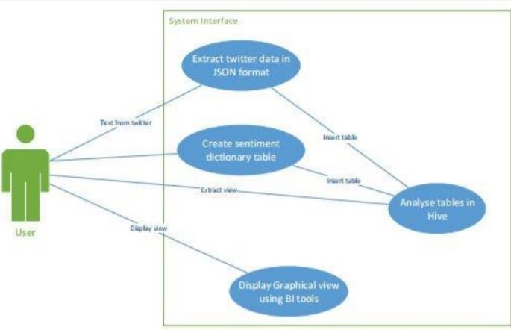

Fig 3.5 Use Case Diagram

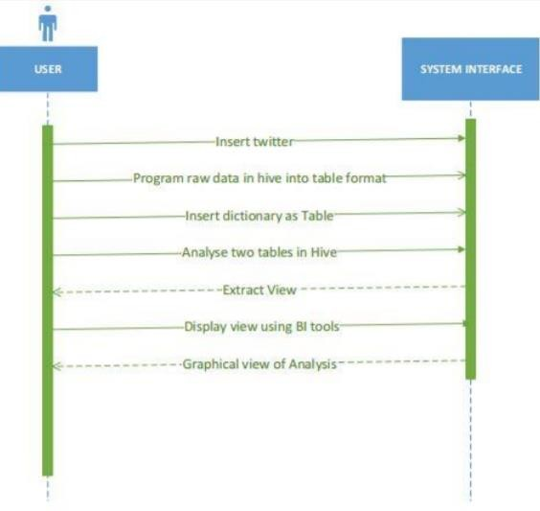

Fig 3.6 Sequence Diagram

# Project implementation

This section consists of all the steps to be followed to achieve the objective of this project. Before starting the implementation, we must understand properly the entire cluster setup procedure in Hadoop as Hadoop works in a distributed and in a parallel manner to store and process the data. Pre-requisites need to be installed first in the machine. Firstly, install Virtual Box on the system. Then install Linux/ Ubuntu in the virtual box. Then, install Java of latest version in the Linux machine.

# Hadoop Cluster setup

A [Hadoop](https://searchcloudcomputing.techtarget.com/definition/Hadoop) cluster is a special type of computational [cluster](https://searchexchange.techtarget.com/definition/cluster) designed specifically for storing and analyzing huge amounts of [unstructured data](https://searchbusinessanalytics.techtarget.com/definition/unstructured-data) in a [distributed computing](https://whatis.techtarget.com/definition/distributed-computing) environment. Such clusters run Hadoop's [open sourc](https://whatis.techtarget.com/definition/open-source)e distributed processing software on low-cost [commodity](https://whatis.techtarget.com/definition/commodity-computer) [computers.](https://whatis.techtarget.com/definition/commodity-computer) Typically one machine in the cluster is designated as the Name Node and another machine as Job Tracker; these are the masters. The rest of the machines in the cluster act as both Data Node and Task Tracker; these are the slaves. Hadoop clusters are often referred to as "shared nothing" systems because the only thing that is shared between nodes is the network that connects them.

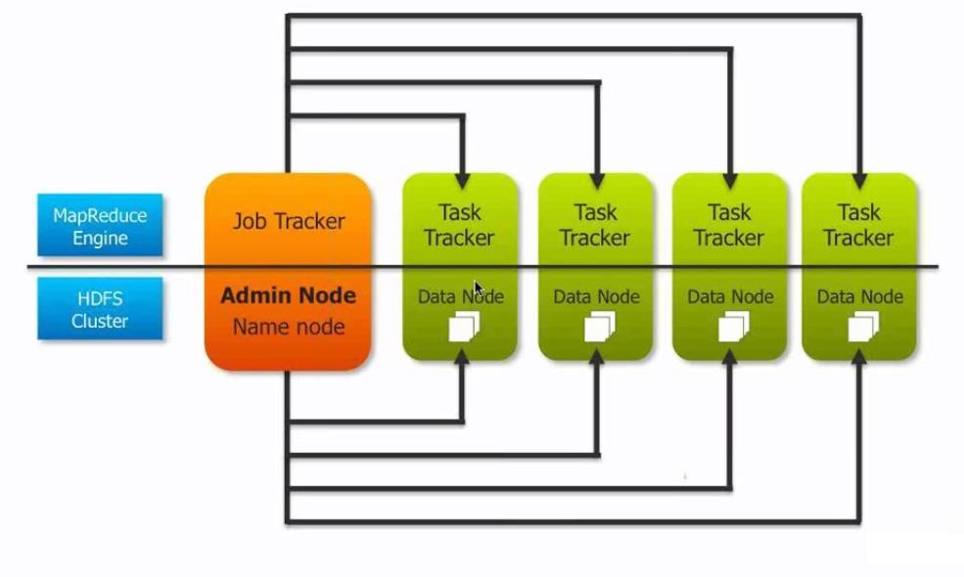

Fig 3.7 Hadoop Cluster Model

Hadoop clusters are known for boosting the speed of data analysis applications. They also are highly scalable: If a cluster's processing power is overwhelmed by growing volumes of [data,](https://searchdatamanagement.techtarget.com/definition/data) additional cluster nodes can be added to increase throughput. Hadoop clusters also are highly resistant to failure because each piece of data is copied onto other cluster nodes, which ensures that the data is not lost if one node fails. As of early 2013, [Facebook](https://whatis.techtarget.com/definition/Facebook) was recognized as having the largest Hadoop cluster in the world. Other prominent users include [Google,](https://searchcio.techtarget.com/definition/Google-The-Company) [Yahoo](https://whatis.techtarget.com/definition/Yahoo) and [IBM.](https://searchitchannel.techtarget.com/definition/IBM-International-Business-Machines)

# Hadoop Cluster Mode setup

* + - 1. Create a folder for Hadoop in “opt” say /opt/hadoop-2.2.0-dist
      2. If you do not have permission for creating folder in opt, you could execute following command to change the mode of “opt” folder

*$ sudo chmod -R xxx /opt/*

(here xxx could be the linux persmission set like 777).

* + - 1. *$cd* /opt/hadoop-2.2.0-dist
      2. Download 2.x version tar.gz file of Hadoop from [here](http://www.bizdirusa.com/mirrors/apache/hadoop/common/)
      3. Untar the file to a folder /opt/hadoop-2.2.0-dist using command:

*$tar -xzvf hadoop-filename.tar.gz*

* + - 1. Move hadoop setup folder to /opt/

$*mv hadoop-2.2.0 /opt/*

* + - 1. $*cd /opt/hadoop-2.2.0*
      2. Before installing hadoop, configure the environment variables: Open or create .bash_profile in home folder of user:

*$ sudo nano ~/.bash_profile*

Enter the following environment variables in this file:

export HADOOP_PREFIX="/opt/hadoop-2.2.0/"

export PATH=$PATH:$HADOOP_PREFIX/bin

export PATH=$PATH:$HADOOP_PREFIX/sbin

export HADOOP_COMMON_HOME=${HADOOP_PREFIX}

export HADOOP_MAPRED_HOME=${HADOOP_PREFIX}

export HADOOP_HDFS_HOME=${HADOOP_PREFIX} export YARN_HOME=${HADOOP_PREFIX}

36

export JAVA_HOME="/usr/lib/jvm/jdk1.7.0" export PATH=$PATH:$JAVA_HOME/bin

* + - 1. Save the file and run command *$source ~/.bash_profile*
      2. Go to /opt/hadoop-2.2.0/etc/hadoop directory and open **core-site.xml**. Enter following properties in it:

<configuration>

<property>

<name>fs.defaultFS</name>

<value>hdfs://hadoopnode1:8020</value>

<final>true</final>

</property>

<property>

<name>io.file.buffer.size</name>

<value>131072</value>

</property>

</configuration>

* + - 1. Go to /opt/hadoop-2.2.0/etc/hadoop directory and open **hdfs-site.xml**. Enter following properties in it:

<configuration>

<property>

<name>dfs.namenode.name.dir</name>

<value>file:///opt/hadoop2.2.0/hadoop_data/dfs/name</value>

</property>

<property>

<name>dfs.blocksize</name>

<value>268435456</value>

</property>

<property>

<name>dfs.namenode.handler.count</name>

<value>100</value>

</property>

<property>

<name>dfs.datanode.data.dir</name>

<value>file:///opt/hadoop-2.2.0/hadoop_data/dfs/data</value>

</property>

</configuration>

Go to /opt/hadoop-2.2.0/etc/hadoop directory and open

**mapred-site.xml**.**template**. Enter following properties in it:

<configuration>

<property>

<name>mapreduce.framework.name</name>

<value>yarn</value>

</property>

</configuration>

13.Goto/opt/hadoop-2.2.0/etc/Hadoopdirectory\andopen**yarn-site.xml**.Enter following properties in it:

<configuration>

<property>

<name>yarn.resourcemanager.address</name>

<value>hadoopnode1:8032</value>

</property>

<property>

<name>yarn.resourcemanager.scheduler.address</name>

<value>hadoopnode1:8030</value>

</property>

<property>

<name>yarn.resourcemanager.resource-tracker.address</name>

<value>hadoopnode1:8031</value>

</property>

<property>

<name>yarn.resourcemanager.admin.address</name>

<value>hadoopnode1:8033</value>

</property>

<property>

<name>yarn.resourcemanager.webapp.address</name>

<value>hadoopnode1:8088</value>

</property>

apache.hadoop.yarn.server.resourcemanager.scheduler.capacity.CapacityScheduler

</value>

</property>

<property>

<name>yarn.nodemanager.aux-services</name>

<value>mapreduce_shuffle</value>

</property>

<property>

<name>yarn.nodemanager.local-dirs</name>

<value>file:///opt/hadoop- 2.6.0/hadoop_data/yarn/yarn.nodemanager.local-dirs</value>

</property>

<property>

<name>yarn.nodemanager.log-dirs</name>

<value>file:///opt/hadoop- 2.6.0/hadoop_data/yarn/logs</value>

</property>

<value>org.

<property>

<name>yarn.resourcemanager.scheduler.class</name>

**Note:** here hadoopnode1 is the hostname of host that would run Resource Manager Go to /opt/hadoop-2.6.0/etc/hadoop directory and open or create

**hadoop-env.sh**.Enter/change java path to your path of java installation :

# export JAVA_HOME=/usr/lib/jvm/jdk1.8.0_05

You can check your java installation path by command:

$*echo $JAVA_HOME*

Edit slaves file and add the worker nodes (the nodes that would run datanode and nodemanager) name or ip address. A single node can act as a Master and Worker node both, but there is only one node in cluster that can act as Master.

$ nano /opt/hadoop-2.6.0/etc/hadoop/slaves Add Node lists as a new line separated entries:

hadoopnode1 hadoopnode2

Enable passwordless ssh between the Master Node( the node running Resource Manager) and Worker Nodes by running following commands on Master node for each Worker node as host:

$ ssh-agent $SHELL

$ ssh-add

$ ssh-copy-id -i hadoopnode1

$ ssh-copy-id -i hadoopnode2

Ensure the passwordless ssh is working fine by doing ssh to some of the nodes as

$ssh user@hadoopnode1

Copy the setup on Master node to all the Worker nodes as:

$scp -r /opt/hadoop-2.2.0 user@hadoopnode2:/opt/

$scp ~/.bash_profile shrey@hadoopnode2:~/

Edit /etc/hosts of all nodes to add mapping of node’s hostname with the ip address for all nodes in the cluster.

#127.0.0.1 localhost

#127.0.1.1 hadoopnode1

192.168.56.101 hadoopnode1

192.168.56.102 hadoopnode2

192.168.56.103 hadoopnode3

Last step before running the service up is to format the namenode, run the command from hadoop folder:

## $hdfs namenode –format

After successful format of namenode, run the hadoop services as:

## $start-all.sh

To check whether the Hadoop services are running or not, type **jps**. Hence, with this our Hadoop cluster mode is installed successfully. In this case, we have only one node in the cluster as we are implementing this project on a single machine. Next, in the further sections, we go according to the project workflow , that is, fetching, loading and analysis.

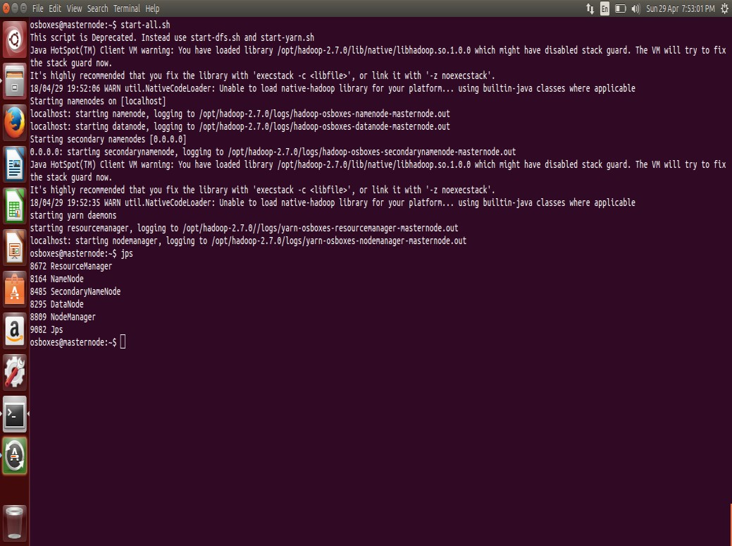

Fig3.8 Hadoop Services Started

**3.6.2 Fetching Real Time data**

This section of the project involves streaming the twitter API, fetching the real time tweets using FLUME and loading the data into HDFS. Let us perform it in a detailed stepwise manner.

# What is Flume

Apache Flume is a tool/service/data ingestion mechanism for collecting aggregating and transporting large amounts of streaming data such as log files, events, etc., from various sources to a centralized data store. Flume is a highly reliable, distributed and configurable tool. It is principally designed to copy streaming data (log data) from various web servers to HDFS.The following illustration depicts the basic architecture of Flume. As shown in the illustration, **data generators** (such as, Facebook, Twitter) generate data which gets collected by individual Flume **agents** running on them. Thereafter, a **data collector** (which is also an agent) collects the data from the agents which is aggregated and pushed into a centralized store such as HDFS or H-base.



Fig 3.9 Flume workflow

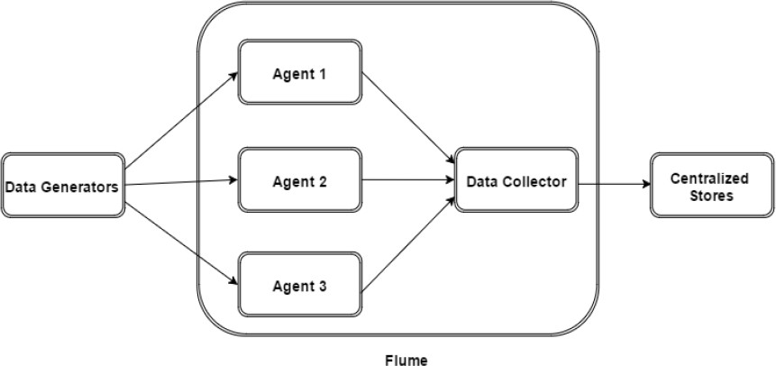

Fig 3.10 Flume Architecture

# Flume Installation

**Step 1:** Download latest Flume release from Apache [Website.](http://archive.apache.org/dist/flume/)

**Step 2**: Move/Copy it to the location you want to install, in my case it is “/opt”.

# $cd Downloads/

**$sudo cp apache-flume-1.6.0-bin.tar.gz /opt/**

Or

Copy by WinSCP into “/opt/”

**Step 3:** Extract the tar file. Go to the copied folder, in my case it is “/opt/”, run the below commands

# $ cd /opt

**$ sudo tar–xzvf /opt/apache-flume-1.6.0-bin.tar.gz**

**Step 4:** Move the “flume-sources-1.0-SNAPSHOT” file into /opt/apache-flume-1.8.0-bin/lib

# By WinSCP

**Step 5:** Update environments

# $ sudo nano ~/.bashrc

Add Below Lines:

# exportFLUME_HOME=“/opt/apache-flume-1.8.0-bin” exportFLUME_CONF_DIR=$FLUME_HOME/conf exportFLUME_CLASSPATH=$FLUME_CONF_DIR

**exportPATH=$PATH:$FLUME_HOME/bin**

**Step 6:** Reload ***.bashrc***

# $ source ~/.bashrc

**Step 7:** Rename “**flume-env.sh.template**” to “**flume-env.sh**” and write the below values.

# $ sudo mv/opt/apache-flume-1.8.0-bin/conf/ flume-env.sh.template flume-env.sh

**$ nano /opt/apache-flume-1.8.0-bin/conf/flume-env.sh**

Add below line (please use your installed java version)

# $JAVA_OPTS="-Xms500m -Xmx1000m -Dcom.sun.management.jmxremote" Export JAVA_HOME=/usr/lib/jvm/java-8-oracle

**FLUME_CLASSPATH="/opt/apache-flume-1.8.0-bin/lib/flume-sources-1.0- SNAPSHOT.jar"**

**Step 8:** Enter as hadoop and run flume CLI:

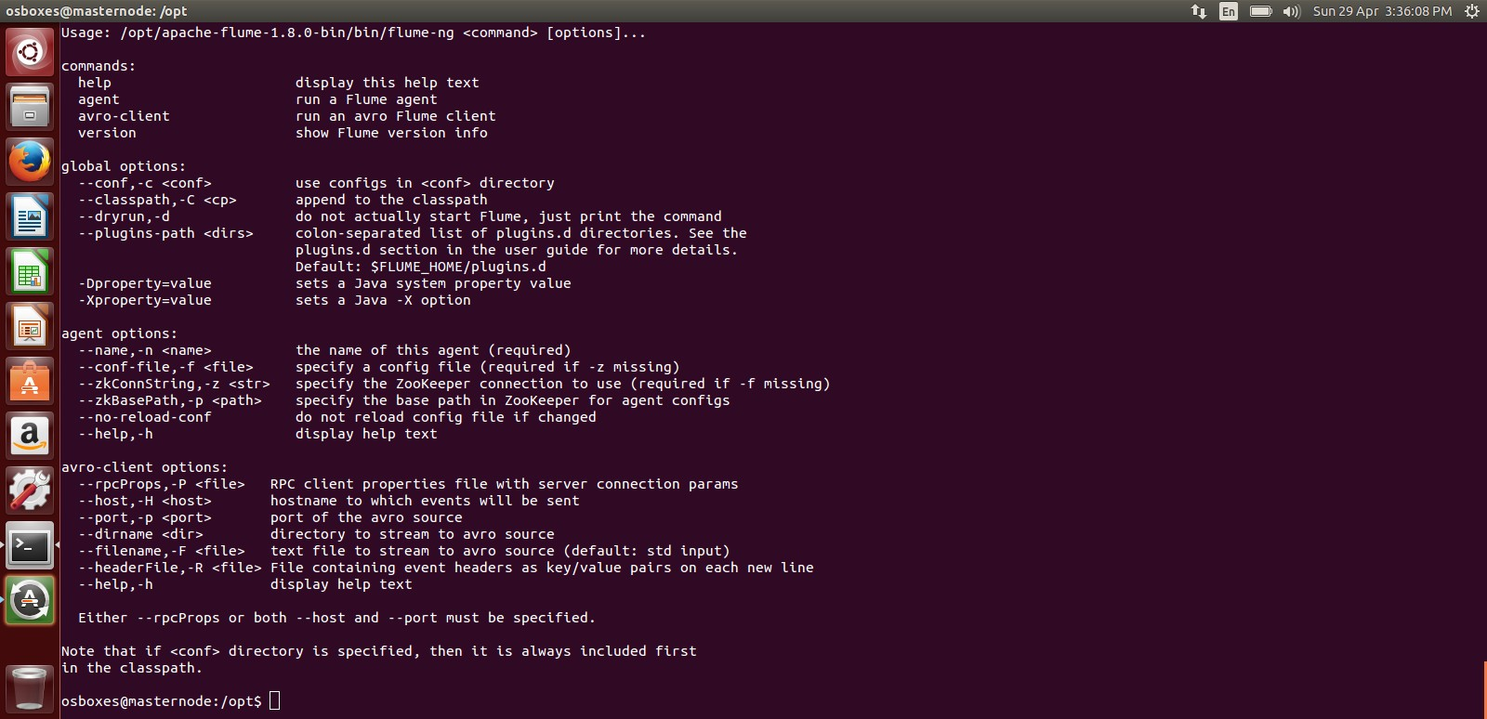

Fig 3.11 Flume Installed

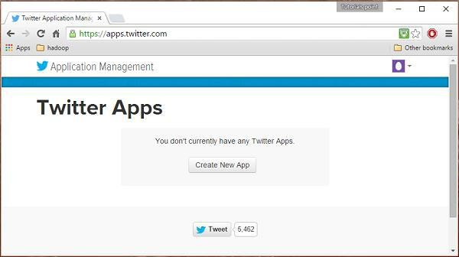

|  |
| --- |
|  |
|  |

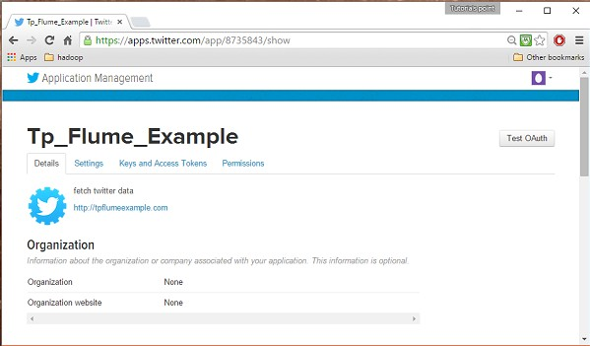Fig 3.12 Twitter API

Fig 3.13 Application Page

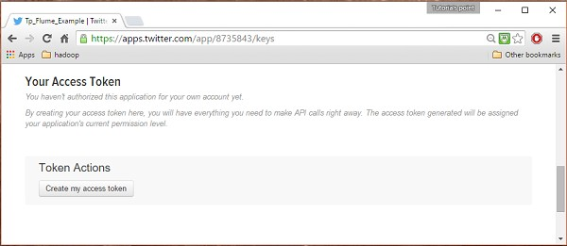

Fig 3.14 Generate Access Token

The four keys are generated- **Consumer Key, Consume Secret Key, Access Token Key, Access Token Secret Key**.

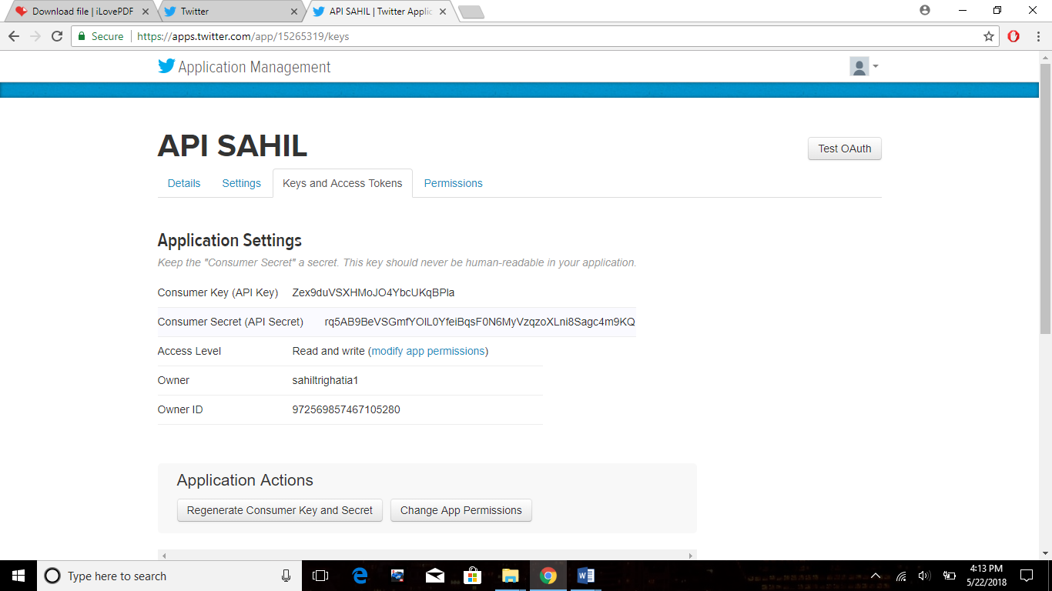**Note: -** You must utilize the Consumer key and Consumer Secret Key within 15 minutes into the Flume code to fetch the data, otherwise these keys get expired after that and you have to regenerate them and add to the code. Also, access token and access token secret key always remain constant and unique. They need not to be re-generated again.33

Fig 3.15 Consumer Key

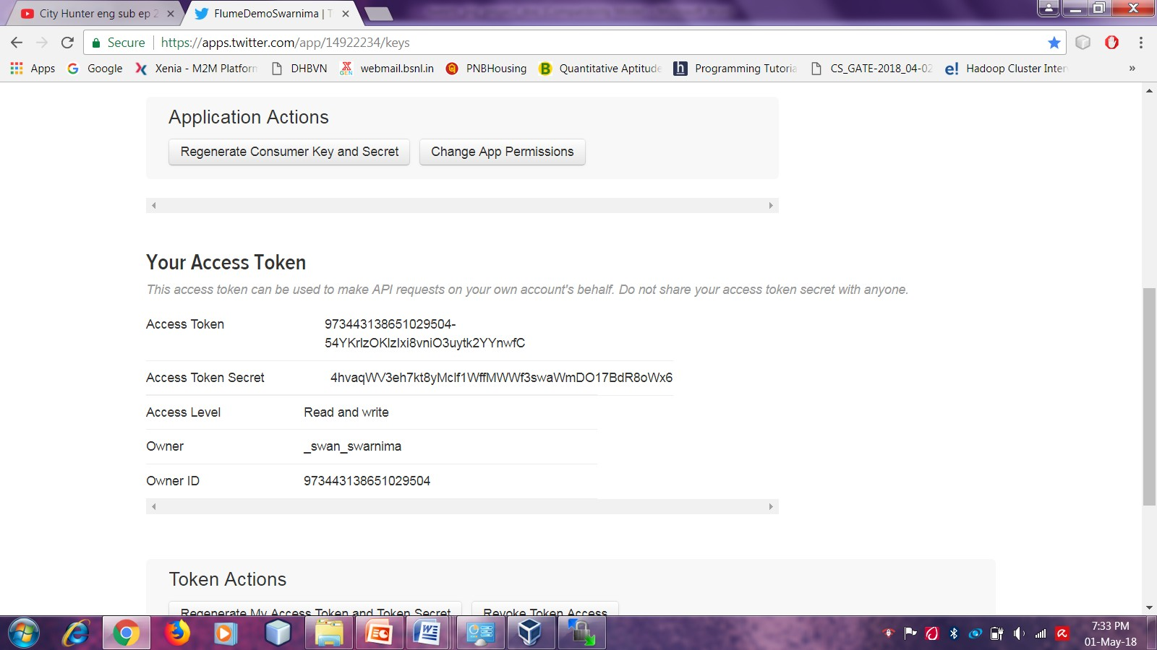

Fig 3.16 Access Token keys

Write configuration file code for flume that will fetch real time twitter data from Twitter and loads in a folder in HDFS. The code is as follows: -

# TwitterAgent.sources = Twitter TwitterAgent.channels = MemChannel TwitterAgent.sinks = HDFS

**TwitterAgent.sources.Twitter.type = org.apache.flume.source.twitter.TwitterSource**

**# Copying the four keys generation in twitter app in this code**

**TwitterAgent.sources.Twitter.consumerKey = nKTKFa9T7T1YgT0790AN1W5uY**

**TwitterAgent.sources.Twitter.consumerSecret=YSOJzEBzc7iN8JnpWWaa4RxiGqD4uCxe 4DGc7Co3AzeDY5Qht**

**TwitterAgent.sources.Twitter.accessToken =973443138651029504-**

**54YKrlzOKlzIxi8vniO3uytk2YYnwfC**

**TwitterAgent.sources.Twitter.accessTokenSecret= 4hvaqWV3eh7kt8yMclf1WffMWWf3swaWmDO17BdR8oWx6**

**TwitterAgent.sources.Twitter.keywords = tutorials point,java, bigdata, mapreduce, mahout**

**# Describing/Configuring the sink check your port no. of HDFS it will be 9000 or 8020**

**TwitterAgent.sinks.HDFS.type = hdfs TwitterAgent.sinks.HDFS.hdfs.path = hdfs://localhost:8020/twitter_data/ TwitterAgent.sinks.HDFS.hdfs.fileType = DataStream TwitterAgent.sinks.HDFS.hdfs.writeFormat = Text TwitterAgent.sinks.HDFS.hdfs.batchSize = 1000**

**TwitterAgent.sinks.HDFS.hdfs.rollSize = 0**

**TwitterAgent.sinks.HDFS.hdfs.rollCount = 10000 # Describing/Configuring the channel**

**TwitterAgent.channels.MemChannel.type = memory TwitterAgent.channels.MemChannel.capacity = 10000**

**TwitterAgent.channels.MemChannel.transactionCapacity = 100 # Binding the source and sink to the channel TwitterAgent.sources.Twitter.channels = MemChannel TwitterAgent.sinks.HDFS.channel = MemChannel**

1.)Now, get into the conf directory of flume by this command:-

# cd /opt/apache-flume-1.8.0-bin/conf

Then, create a file named as **twitter.conf** in this directory-

# Sudo nano twitter.conf

Now, copy the above code (step 2) in this file. Then save it- Ctrl+X+Y.

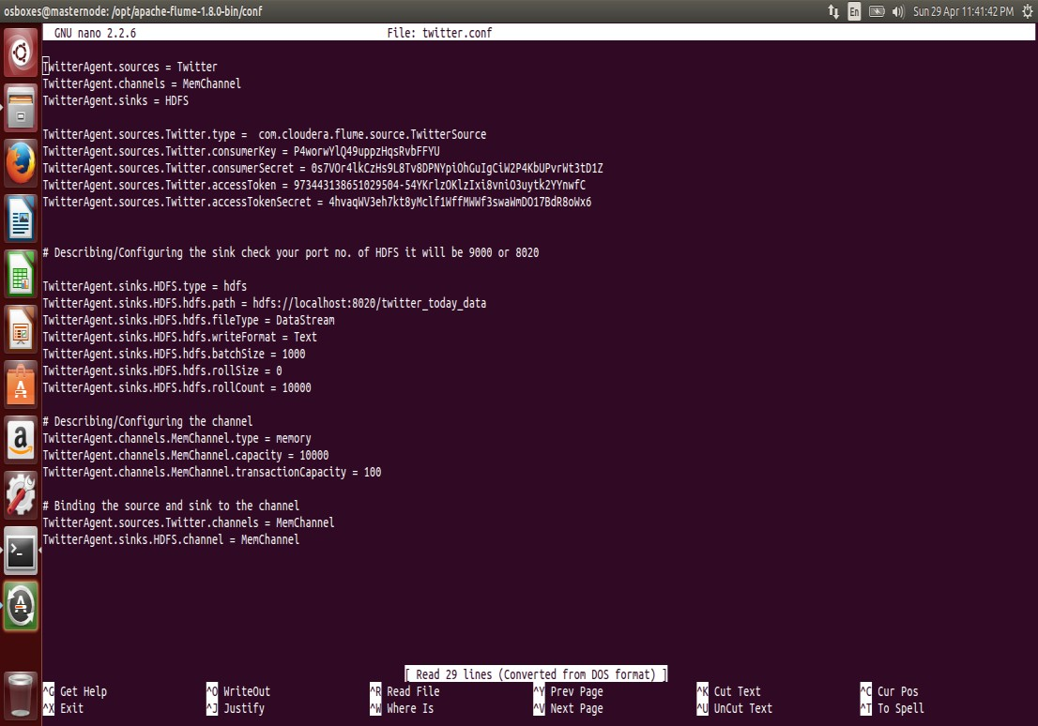

Fig 3.17 Twitter.conf file Now, the final fetching of data. Switch to **bin** directory of flume-

# cd /opt/apache-flume-1.8.0-bin/bin

And, write this command-

# ./flume-ng agent -n TwitterAgent -c conf -f ../conf/twitter.conf Explaination of the command-

flume-ng – shell script located in bin directory of Flume agent – it includes source, channel and sink and thus we need to specify agent name (here, TwitterAgent). Source links with the web server and fetches the data, it passes through Channel and thus Sink into HDFS. Agent –n : specifies the name of the agent. -c conf : it opens configuration directory -f ../conf/twitter.conf: it specifies the

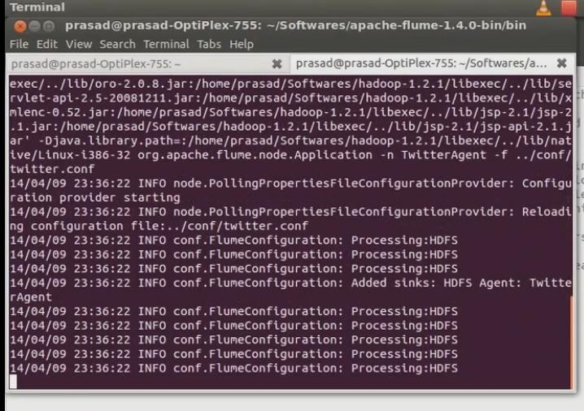

Fig 3.18 Connection Initiated

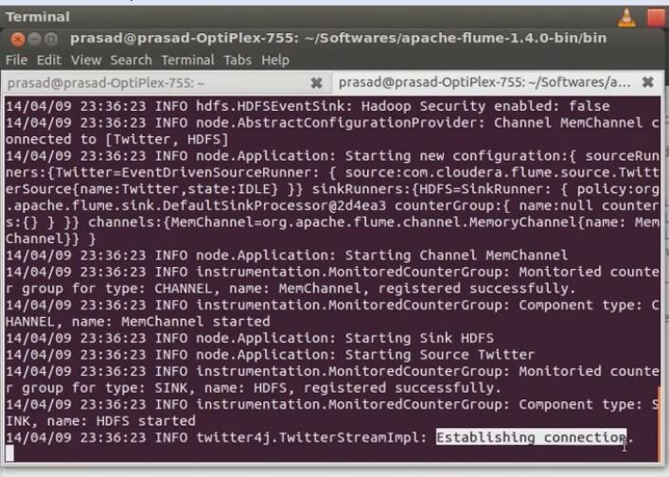

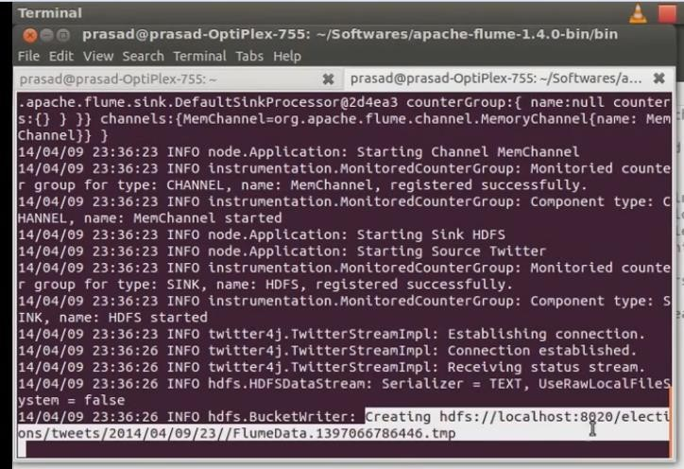Fig 3.19 Connection Established

Fig 3.20 Files Created

The extracted real time Twitter Data gets stored in the form of files in the HDFS.

1. The above command fetches data from twitter API using FLUME and automatically dumps the data into HDFS. To check the fetched data into HDFS, go to browser and open the name node- http://192.168.56.101:50070/explorer.html#/ Click the folder you mentioned in the code in the fetched data needed to be stored (here, twitter_today_data). You can see the number of files appeared into it, where each file consists of numerous tweets.

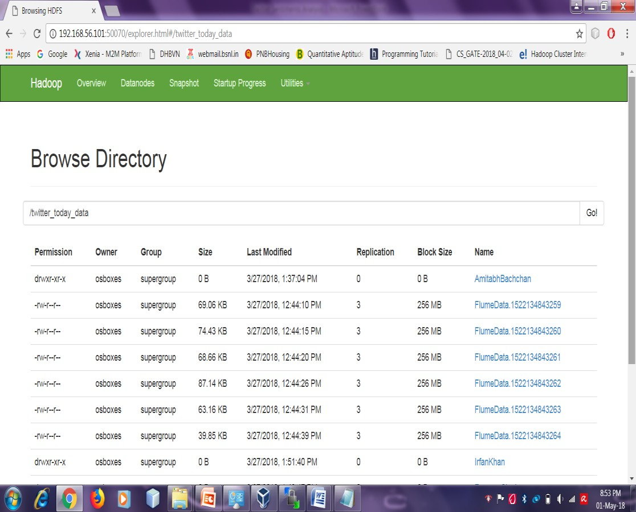

Fig 3.21 HDFS Browse Directory

To open one the files, to see the fetched tweets-

Type command- **hadoop fs –cat /twitter_data/FlumeData.1520875895715**

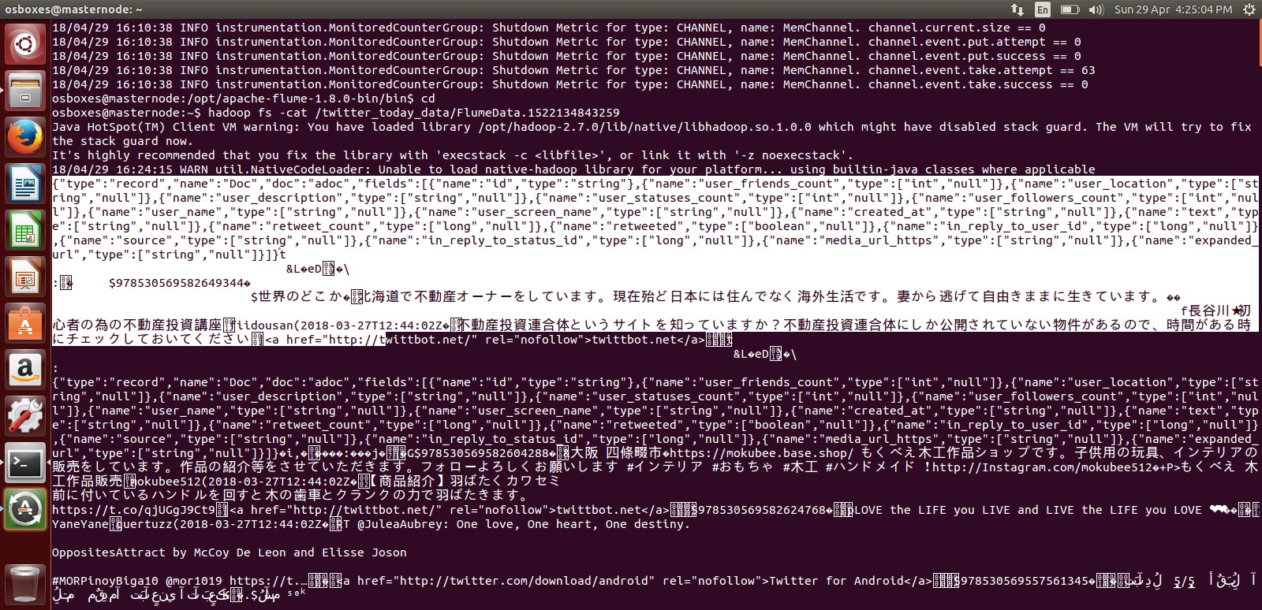

Fig 3.22 Twitter Data in JSON Format

Therefore, we have successfully extracted real time data from Twitter. Now, to use the meaningful data out of it, we need to process the data which is described in detail in the next section.

# Processing Twitter Data

how we are going to read data that is in the form of JSON format for that we are using the custom serde for the JSON format so that our HIVE can read JSON data and can create a table in our prescribed format.Before, starting the Data processing, we must ensure that Hive is installed in the From these data first we want to create a table where the filtered data want to set into a formatted structure such that by which we can say clearly that we have converted the unstructured data into structured format. For this we have to use some custom serde concepts. These concepts are nothing but machine and is active. So, let us know Hive in brief and steps to install it.

# What is Hive

**Apache Hive** is a data warehousing package built on the top of Hadoop that is used for data analysis. It was developed by Facebook to target towards users comfortable with SQL. Thus it is quite similar to SQL, it is also called HiveQL. It abstracts complexity of Hadoop as there is no need to learn Java and Hadoop APIs and therefore, used for managing and querying structured data. Facebook analyzes several Terabytes of data everyday using Hive. It abstracts complexity of Hadoop as there is no need to learn Java and Hadoop APIs and therefore, used for managing and querying structured data. Facebook analyzes several Terabytes of data everyday using Hive.

# Hive Installation

Download Hive latest version (During this tutorial hive-2.1.1 is the latest) from this [link](http://apache.mesi.com.ar/hive/hive-2.1.1/apache-hive-2.1.1-bin.tar.gz) (Use this link through CD). you will get “***apache-hive-2.1.1-bin.tar.gz*** ” file. Extract it to the folder where you want to install Hive. For that you can use ArchiveManager or by terminal using the command **tar -xzf apache-hive-2.1.1-bin.tar.gz**

Setting up environment for Hive Edit .bashrc

# Sudo nano ~/.bashrc

Add **HIVE_HOME** path

# export HIVE_HOME="/usr/local/hive"

# export PATH=$PATH:$HIVE_HOME/bin

Reload .bashrc **Source ~/.bashrc**

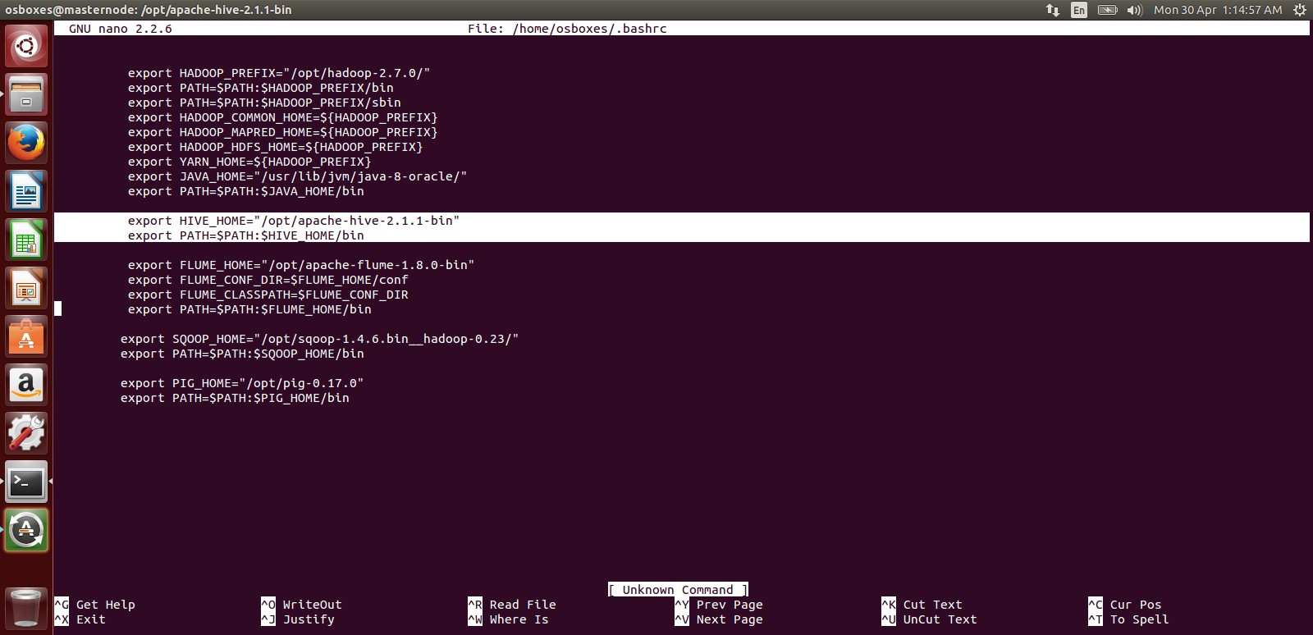

Fig 3.23 Giving Path in Bashrc

Edit **hive-config.sh**

Now, go to your hive directory and add HADOOP_HOME path. To do that follow below steps.

Open ***hive-config.sh*** file

# cd /usr/local/hive

**gedit bin/hive-config.sh**

Add **HADOOP_HOME** path

# export HADOOP_HOME=/usr/local/Hadoop

(your hadoop installation directory) Delete log4j-slf4j-impl-2.4.1 jar file

We have to delete the jar file named “***log4j-slf4j-impl-2.4.1.jar*** “, which is located in “***lib***” folder

of your hive directory. This is because hadoop has another log4j jar and when we run hive, there will be ambiguity to choose a log4j file and thus results in an error. So, we delete this log4j-slf4j- impl-2.4.1.jar file in “***apache-hive-2.1.1-bin/lib*”**folder.

# rm lib/log4j-slf4j-impl-2.4.1.ja

Create Warehouse folder in HDFS file system Before running Hive, we have to create a ***warehouse*** folder for Hive in the HDFS file system. For that , start HDFS and yarn by running the following commands.

# sbin/start-dfs.sh , sbin/start-yarn.sh

Check whether all the processes are running or not using **jps** command. If all the hadoop processes are running, then create a ware house folder in HDFS using the command-

**Hadoop fs -mkdir -p /usr/hive/warehouse** Now, provide read/write permissions to that folder using the command

**Hadoop fs -chmod 777 /usr/hive/warehouse** Set default database type.

By default hive uses Derby, but still we have to specify it using ***“schematools”*** before running hive. To do that Open a terminal run the following commands.

# schematool -initSchema -dbType derby

Then, it will show a success message. If it doesn’t show a success message, then run the following commands.

# mv metastore_db metastore_db.tmp

# schematool -initSchema -dbType derby

Check whether all the processes are running or not using **jps** command. If all the hadoop processes are running, then create a ware house folder in HDFS using the command- **Hadoop fs -mkdir -p**

**/usr/hive/warehouse** Now, provide read/write permissions to that folder using the command



Fig 3.24 Success Message

That’s it. Our hive installation is complete…!!

Run Hive

# hive

To run hive, just open a terminal and run hive. You will see a screen like below.



Fig 3.25 Hive Started

# 3.7.3.2 Data Processing Through Hive

Download **hive-serdes-1.0-SNAPSHOT.jar**. Copy the jar file into lib directory of your installed Hive folder. Add the jars to Hive by typing this command-

# ADD jar <path of the jar file>;

Fig 3.26 Adding Jar to Hive

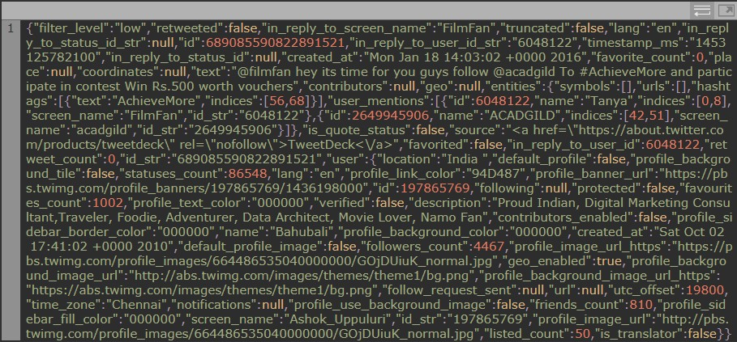

Fig 3.27 Twitter Data in JSON Format

Now, let’s create an external table in Hive in the same directory where our tweets are present, so that tweets which are present in that location will be automatically stored in the Hive table.

The command for creating a Hive table to store id and text of the tweets is as follows:

# create external table load_tweets(id BIGINT,text STRING) ROW FORMAT SERDE 'com.cloudera.hive.serde.JSONSerDe' LOCATION '/user/flume/tweets'

(Now, more about external table and serde in Hive in Appendix 1) We can check the schema of the table using the below command:

# Describe load_tweets;

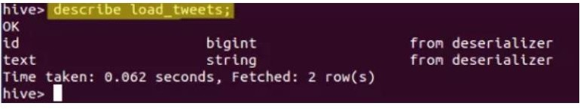

Fig 3.28 Describe The Hive Table

In the above image, we can see that the created Hive table has two rows id and text.

We can view the tweet_id and tweet_text which are present in the table by using the below command:

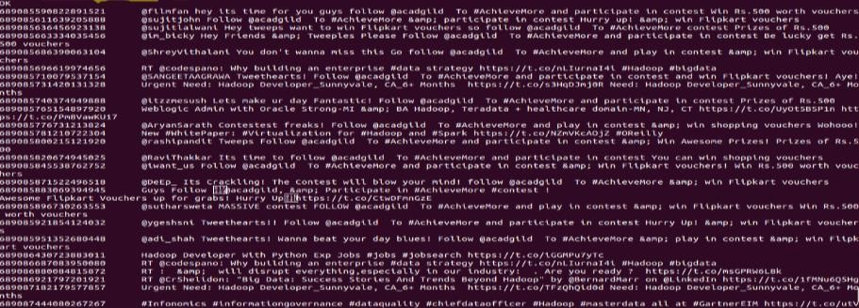**Select*fromload_tweets**

Fig 3.29 Loaded Tweets into Hive

Next, we will split the text into words using the **split()** UDF available in Hive. If we use the split() function to split the text as words, it will return an array of values. So, we will create another Hive table and store the tweet_id and the array of words.

# create table split_words as select id as id,split(text,' ') as words from load_tweets;

We can see the schema of the table by using the ‘describe’ command.

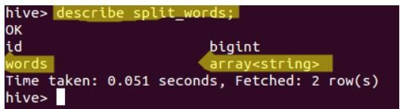

Fig 3.30 Describe Split_Words

Now, we can view the contents of the table by using the below command:

# Select*from split_words

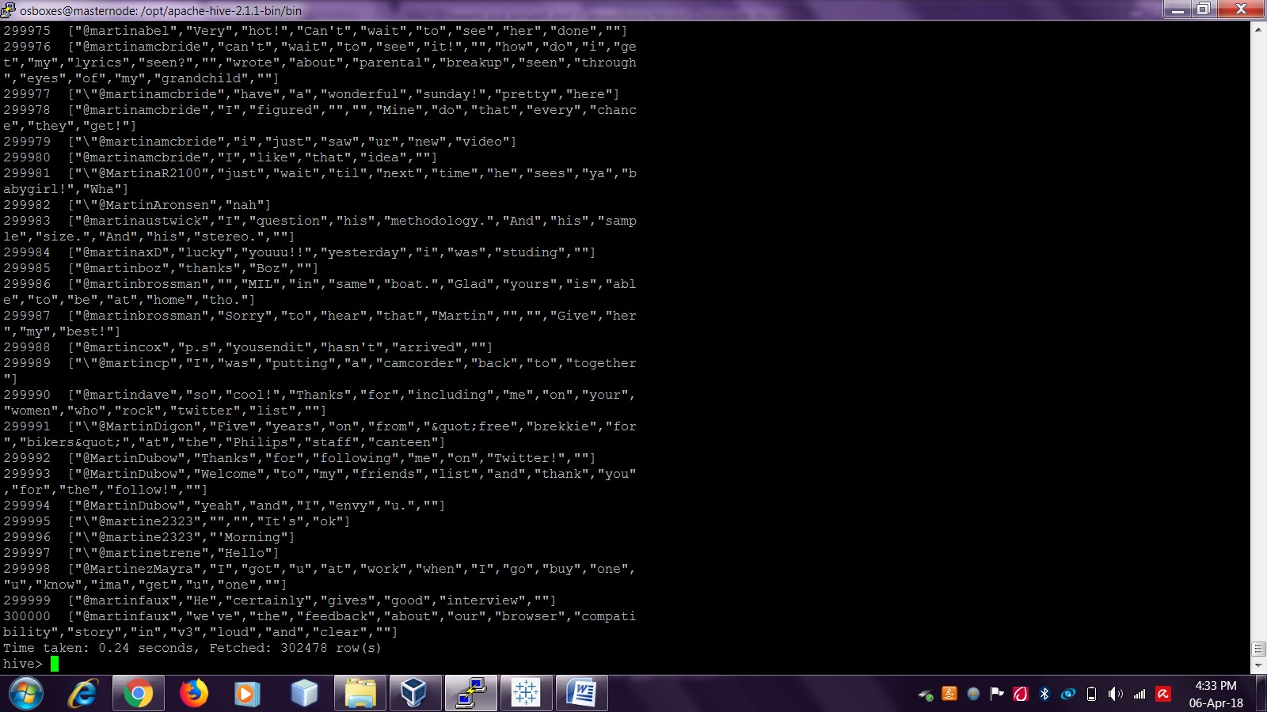

Fig 3.31 Tweets Split Into Array Of Strings

Next, let’s split each word inside the array as a new row. For this we need to use a UDTF(User Defined Table Generating Function). We have built-in UDTF called **explode** which will extract each element from an array and create a new row for each element. This table is named as tweet_word. Now, let us create another table which can store id and word.

# create table tweet_word as select id as id,word from split_words LATERAL VIEW explode(words) w as word;

(Now, more about Lateral View explode UDTF in Appendix 2) We can see the schema of the table by using the ‘describe’ command.

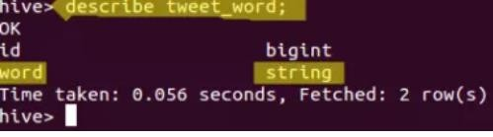

Fig 3.32 Describe Tweet_Word

In the above image, we can see that the array of values has been converted into a string, we can see the contents of the table by using the following command:

# Select*fromtweet_word;

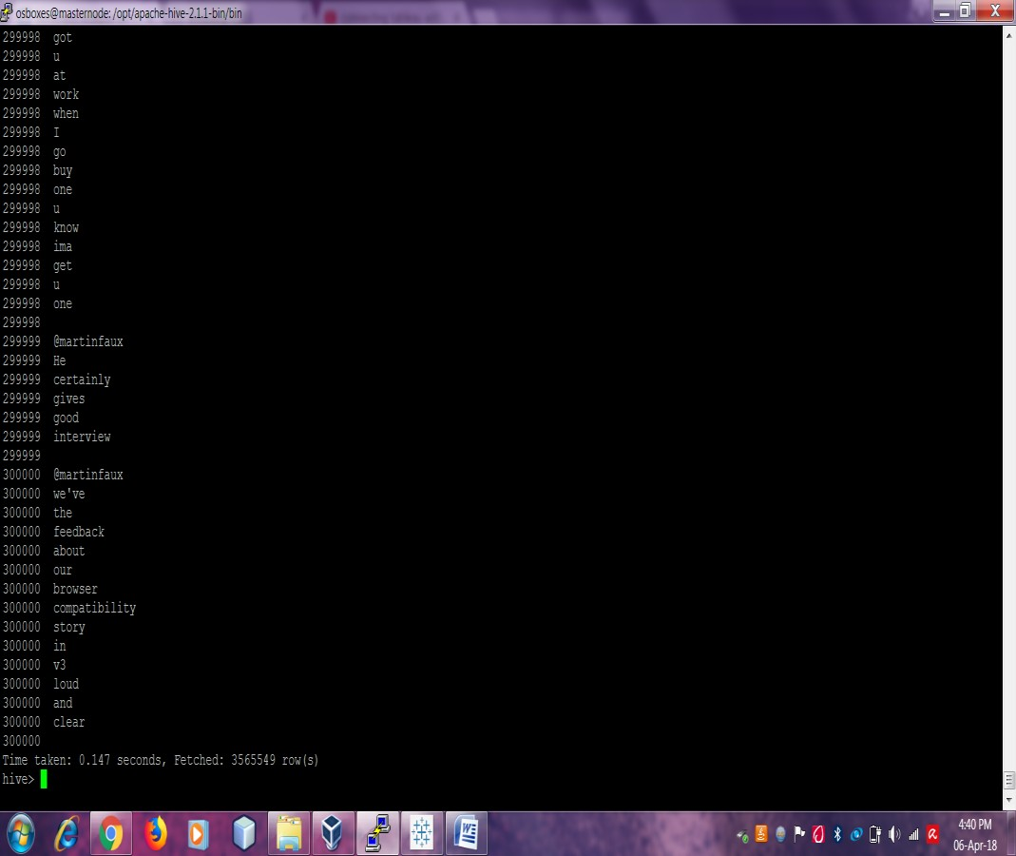

Fig 3.33 View the table

In the above image, we can see that the array of words has been split as one word in a new row.

Let’s use a dictionary called AFINN to calculate the sentiments. AFINN is a dictionary which consists of 2500 words rated from +5 to -5 depending on their meaning.

We will create a table to load the contents of AFINN dictionary. You can download the dictionary from the below link:

[AFINN dictionary](https://drive.google.com/open?id=0ByJLBTmJojjzZ0d1RVdBTDVjT28) (Use this link from a CD)

# create table dictionary(word string,rating int) ROW FORMAT DELIMITED FIELDS TERMINATED BY '\t';

Now, let’s load the AFINN dictionary into the table by using the following command:

# LOAD DATA INPATH '/AFINN.txt' into TABLE dictionary;

We can view the contents of the dictionary table by using this command:

# select * from dictionary;



Fig 3.34 AFINN Dictionary

Now, we will join the **tweet_word table and dictionary table** so that the rating of the word will be joined with the word.

**create table word_join as select tweet_word.id, tweet_word.word, dictionary.rating from tweet_word LEFT OUTER JOIN dictionary ON(tweet_word.word =dictionary.word);**

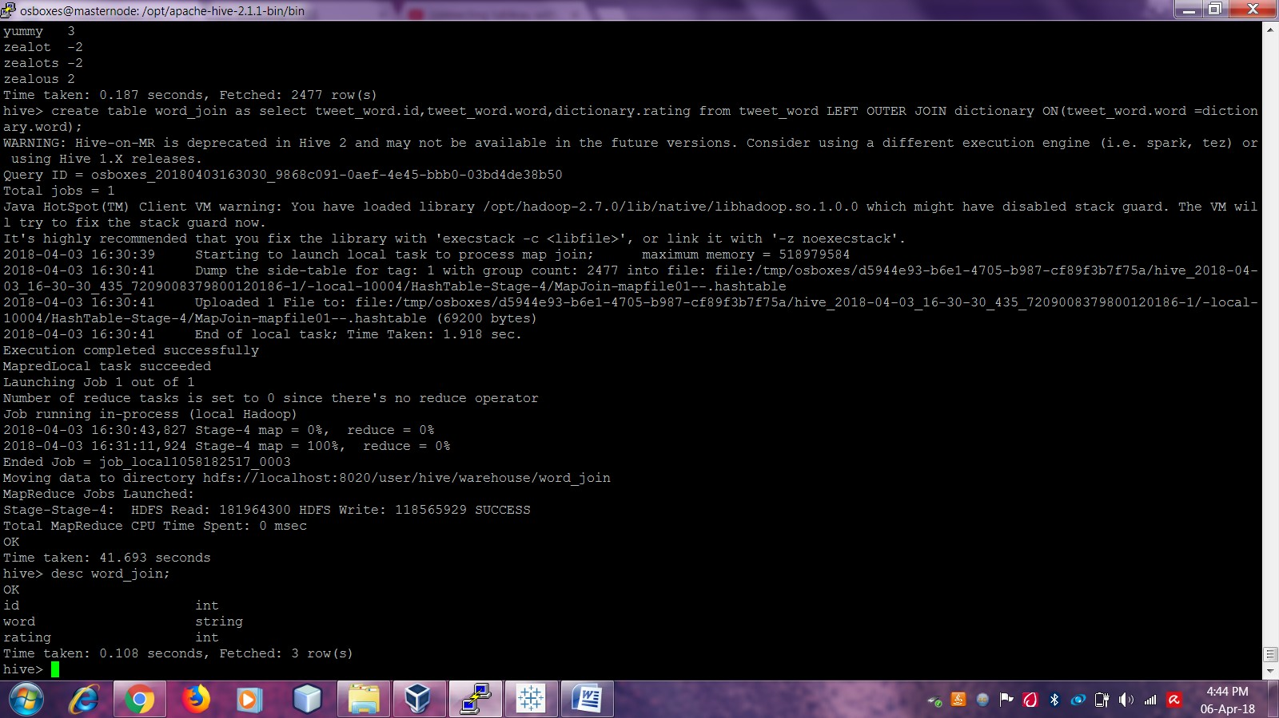

Fig 3.35 Word Join table created

We can see the schema of the table by describing it.

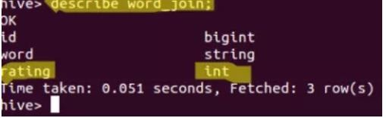

Fig 3.36 Describe to see schema

In the above image, we can see that the rating column has been added along with the id and the word. Whenever there is a match with the word of the tweet in the dictionary, the rating will be given to that word else NULL will be present. Let’s view the contents of the table by using the below command:

# Select*from word_join



Fig 3.37 All the words have been rated

Now we will perform the ‘***groupby***’ operation on the tweet_id so that all the words of one tweet will come to a single place. And then, we will be performing an Average operation on the rating of the words of each tweet so that the average rating of each tweet can be found.

# select id,AVG(rating) as rating from word_join GROUP BY word_join.id order by rating DESC;

In the above command, we have calculated the average rating of each tweet by using each word of the tweet and arranging the tweets in the descending order as per their rating. Now we will perform the ‘***group by***’ operation on the tweet_id so that all the words of one tweet will come to a single place. And then, we will be performing an Average operation on the rating of the words of each tweet so that the average rating of each tweet can be found. so that all the words of one tweet will come to a single place. And then, we will be performing an Average operation on the rating of the words of each tweet so that the average rating of each tweet can be found.



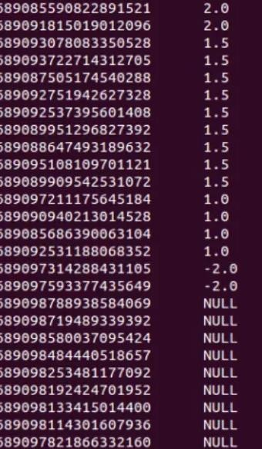 Fig 3.38 Tweets Positive, Negative And Neutral

Fig 3.39 Classified Tweets

Thus, we finally get a processed data using apache hive that consists of classified tweets- ***positive***

Tweets, ***negative*** tweets and ***neutral*** tweets with respect to the tweet_id.

# Data Visualization

This is the last stage of the project where we finally visualize the analyzed data output in the form of graphical representations. Before jumping directly to the steps, let us have a brief introduction about this stage.

# What is Data Visualization

One of the most important benefits of visualization is that it allows us visual access to huge amounts of data in easily digestible visuals. Well-designed data graphics are usually the simplest, and at the same time, the most powerful. Possible processes includes,

* + - 1. Data mining, understanding a potential strategy and story. This is the **discovery phase**.
      2. Research, design and development teams come in here, processing information and building a user friendly tool. This is the **visualization phase**.
      3. A web experience is created giving the user a data-driven experience. This is the

# Experience phase.

Data visualization (Data graphics) helps you to understand trends, patterns and to make correlations. They are typically instruments for reasoning about quantitative information.

To visualize the analyzed data by Hadoop, there are various tools like advanced Excel, Google Charts, R studio, Tableau and many more. Here, in this project we have used **Tableau 10.5** software to visualize the data.

**Note:-** Since Tableau has currently access to only cloud era Hadoop and not to apache, we have performed the same hive processing in cloud era quick start vdi (it includes all the frameworks pre- installed so we only need to start hive and do entire processing).

# Procedure to visualize the data

Install Tableau 10.5 (the current latest version) on the machine.

Also, download Cloudera Hive ODBC Driver for 64-bit or 32-bit and install it. For Driver DSN Setup, follow these steps-

* + - * 1. Start>>All Programs>>64-bit ODBC Administrator
        2. Click System Drivers>>Cloudera Hive ODBC Driver>>Add>>Finish
        3. Configure the Driver DSN Setup

In the Hadoop terminal, type **hive –service hiveserver2.** This will activate the hive server for driver connection between tableau and cloud era hive. Now, Open to Tableau, Click on More Servers.. on the Left side column. Search and select Cloud era Hadoop. In the dialog box, Enter server as hiveserver2, host as IP address (in my case, it is 192.168.56.101), port number as 10000, give your username password of the Hadoop cluster (that you enter to log in your terminal). Click Sign In.Then in the new window, on the Left side window, under schema upload the table name (say, word join). Then it will start showing Dimensionsand Measureson the left side of the window. These divisions consist of the fields and factors of the schema. Drag and drop them into the respective **c**olumn and row. Click on the sheet right at the outer bottom edge of dimension window at the left side. This will show the graphical representation of the table. Also, there is choice between the types of graphs given at the right side of the window. In the Hadoop terminal, type **hive –service hiveserver2.** This will activate the hive server for driver connection between tableau and cloud era hive. Now, Open to Tableau, Click on More Servers. on the Left side column. Search and select Cloud era Hadoop. In the dialog box, Enter server as hiveserver2, host as ip address (in my case, it is 192.168.56.101), port number as 10000, give your username password of the Hadoop cluster (that you enter to log in your terminal). Click Sign In.Then in the new window, on the Left side window, under schema upload the table name (say, word join). Then it will start showing Dimensions and Measureson the left side of the window. These divisions consist of the fields and factors of the schema. Drag and drop them into the respective column and row. Click on the sheetright at the outer bottom edge of dimension window at the left side. This will show the graphical representation of the table. Also, there is choice between the types of graphs given at the right side of the window. Then it will start showing Dimensions and Measureson the left side of the window. These divisions consist of the fields and factors of the schema. Drag and drop them into the respective column and row. Click on the sheet right at the outer bottom edge of dimension window at the left side. This will show the graphical representation of the table. Also, there is choice between the types of graphs given at the right side of the window. In the Hadoop terminal, type **hive –service hiveserver2.**

# CHAPTER 4

**Evaluation of Training (result and output)**

* 1. **Streaming twitter API**

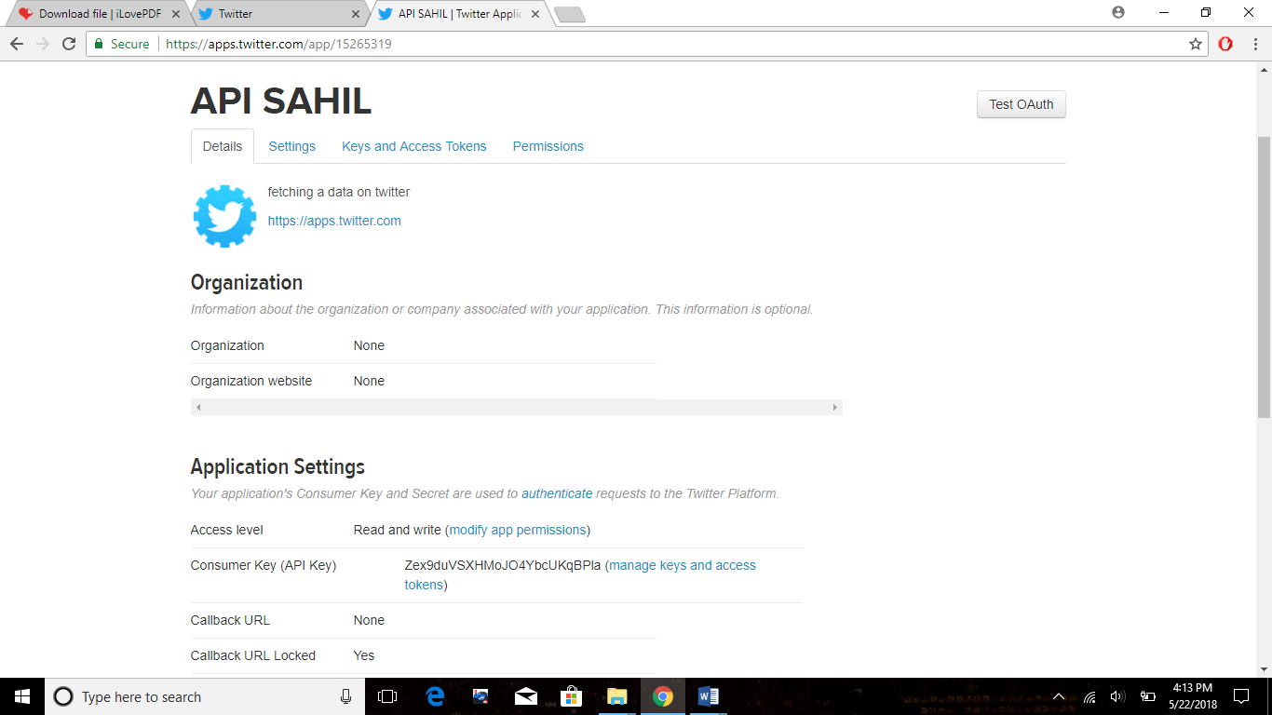

Fig 4.1 Twitter Apps created



Fig4.2Tokens Generated

# LOADING DATA IN HDFS



Fig 4.3 Files Created in HDFS



Fig 4.4 Output Twitter Data in JSON

# Data Analysis Using Hive



Fig 4.5 Processing Twitter Data



Fig 4.6 Tweets- positive, negative and neutral

# Analyzed Data Visualization

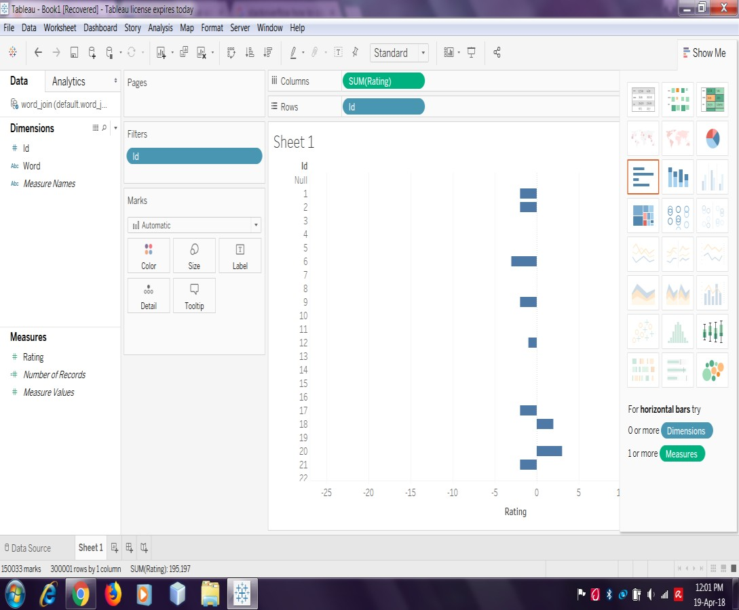

Fig 4.7 Horizontal Bar graphs

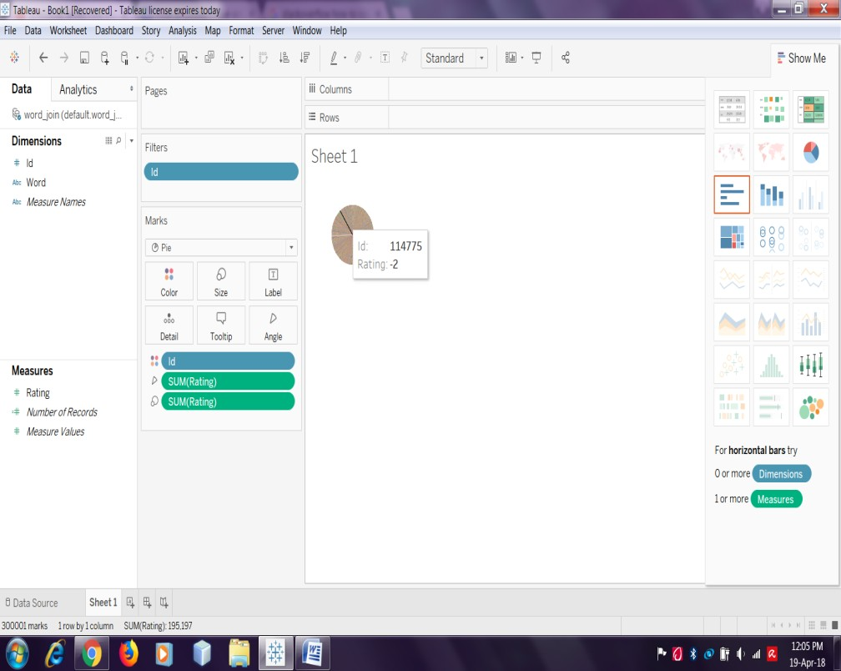

Fig 4.8 Pie Chart Representation

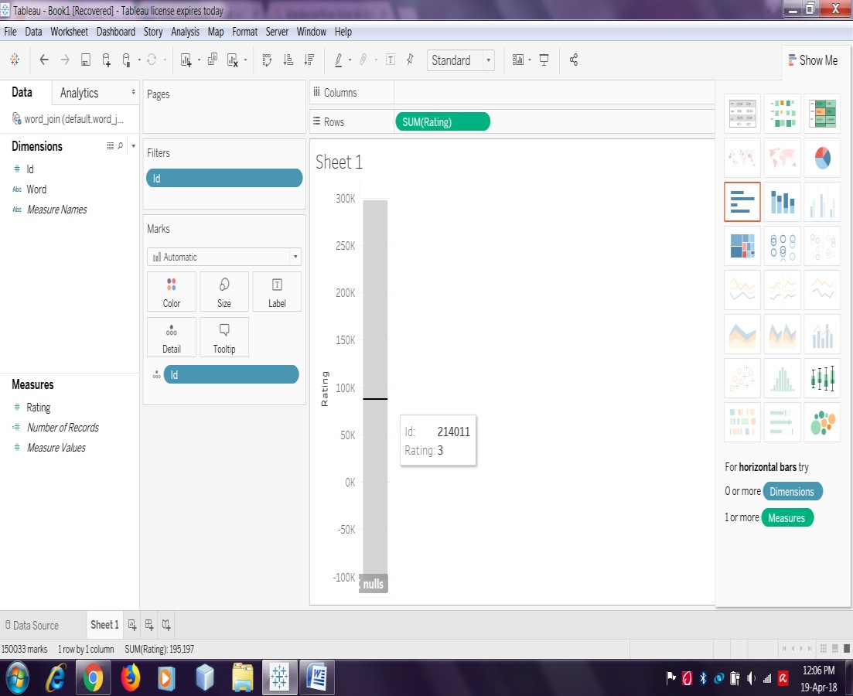

Fig 4.9 Rectangular Graph Representation

# CHAPTER 5

**Conclusion and future scope of training**

**5.1 Conclusion**

Hadoop has its own framework that includes algorithms like Map Reduce, HDFS etc. The entire Hadoop algorithm is coded in Java. It works in an environment that has distributed storage and computation capability across multiple clusters. Map Reduce in Hadoop handles large amount data by breaking it into multiple sets and executing the jobs on the data over a series of server nodes. It’s a batch-mode technology instead of an interactive GUI based application. Hadoop’s architecture has four main elements:

1.      Hadoop Common: These consist of Java utilities and libraries that are required by Hadoop modules and its applications. They also have the OS and file system information to start Hadoop.

2.      Hadoop YARN**:**This application within Hadoop supports cluster management and job scheduling.

3.      Hadoop Distributed File System (HDFS): This is a distributed file system that ensures high-throughput access and processing of data.

4.      Hadoop Map Reduce**:** The framework helps in the parallel processing of the jobs and tasks on the Big-data.

The HDFS is the file system that Hadoop has built in it. It is a portable, scalable, and distributable file system written in the programming language Java. It breaks the large files into small ones and stores them across multiple machines. This removes the requirement of a disk to store data on host machines. Data is stored on nodes called Data Nodes and they interact with one another to replicate data and move data copies. This helps in preventing data loss from the system. The world is changing the way it is operating currently and Big-data is playing an important role in it. Hadoop is a framework that makes an engineer’s life easy while working on large sets of data. There are improvements on all the fronts.  The future is exciting. Hadoop has its own framework that includes algorithms like Map Reduce, HDFS etc. The entire Hadoop algorithm is coded in Java. It works in an environment that has distributed storage and computation capability across multiple clusters. The HDFS is the file system that Hadoop has built in it. It is a portable, scalable, and distributable file system written in the programming language Java.

# 5.2 Future Scope

The Big Data Hadoop will be used to save time in the future. As predicted by IOT by 2020 every individual will generate a data of around 7mb per sec and there will be around 20 million devices by 2020 hence with increase in the number of devices and the amount being generated by individual will increase to a large extent. Big Data Hadoop having the potential of storing, analyzing and processing this huge amount of data hence will be proved of great use. Sentiment analysis is a set of methods, typically implemented in computer software, that detect, measure, report, and exploit attitudes, opinions, and emotions in online, social, and enterprise information sources.

**REFERENCES**

[1] https://www.slideshare.net/easylearninguru/big-data-hadoop-training-by-easylearning-guru

[2] https://www.cognoscape.com/brief-history-of-information-technology-security/

[3] https://www.slideshare.net/mongodb/mongodb-iot-city-tour-stuttgart-hadoop-and-future-data-management-by-cloudera

[4] https://www.districtdispatch.org/2018/02/free-webinar-building-local-communities-social-media/

[5] https://hortonworks.com/blog/data-driven-decisions-financial-services/

[6] http://crossing-technologies.com/big-data-analytics/

[7] https://www.researchgate.net/figure/The-five-Vs-of-Big-Data-Adapted-from-IBM-big-data-platform-Bringing-big-data-to-the_fig1_281404634

[8] https://www.researchgate.net/figure/The-3-Vs-of-Big-Data-Volume-variety-and-velocity-have-been-widely-accepted-as-the-key_fig1_292142503

[9] https://www.researchgate.net/figure/313400371_fig3_Figure-4-Examples-of-big-data-velocity

[10] http://phplot.sourceforge.net/phplotdocs/ex-bars4.html

[11] http://upxacademy.com/beginners-guide-to-big-data/

[12] https://www.mytechlogy.com/IT-blogs/7151/the-four-vs-of-big-data/

[13] https://www.slideshare.net/NAED_Org/naed-big-data

[14] https://www.slideshare.net/EdurekaIN/what-is-hadoop-introduction-to-hadoop-hadoop-tutorial-hadoop-training-edureka

[15] https://www.slideshare.net/EdurekaIN/big-data-tutorial-for-beginners-what-is-big-data-big-data-tutorial-hadoop-training-edureka

[16] https://www.slideshare.net/EdurekaIN/what-is-hadoop-introduction-to-hadoop-hadoop-tutorial-hadoop-training-edureka

[17] https://lakshmana-msbi.blogspot.com/2016/01/big-data-hadoop-lesson-5-namenode.html

[18] https://hadoop.apache.org/docs/r1.2.1/hdfs_design.html

[19] http://www.dummies.com/programming/big-data/hadoop/data-blocks-in-the-hadoop-distributed-file-system-hdfs/

[20]https://data-flair.training/bloghttps:

[21] https://www.dezyre.com/hadoop-tutorial/hadoop-mapreduce-tutorial-

[22] https://www.tutorialspoint.com/apache_flume/apache_flume_quick_guide.htm

[23] https://www.tutorialspoint.com/apache_flume/apache_flume_architecture.htm

[24] https://mapr.com/blog/apache-hive/

[25] https://www.edureka.co/blog/hadoop-ecosystem

[26] https://acadgild.com/blog/integrate-mysql-sqoop

[27] https://sopinion8ed.wordpress.com/tag/sentiment-analysis/

[28] https://marketing.adobe.com/resources/help/en_US/social/c_sentiment_architecture.html